Test Report

**CONTENTS**

Tests and defects2

Testcase Summary2.1

Testcase coverage2.2

Defect Management2.3

Test Execution 3

|  |  |  |  |  |  |  |  |
| --- | --- | --- | --- | --- | --- | --- | --- |
| **Functionality** | **Total test cases** | **No. of untested cases** | **Passed cases** | **Failed cases** | **Execution percentage** | **Completion**  **percentage** | **state** |
| user registration | 5 | 0 | 5 | 0 | %100 | %100 | Pass |
| User login | 6 | 1 | 5 | 0 | %83.3 | %100 | Pass |
| User profile | 7 | 0 | 7 | 0 | %100 | %100 | Pass |
| Skills | 3 | 0 | 3 | 0 | %100 | %100 | Pass |
| Quizzes | 6 | 0 | 6 | 0 | %100 | %100 | Pass |
| Vocabulary page/game | 2 | 0 | 2 | 0 | %100 | %100 | Pass |
| Read more button | 1 | 0 | 1 | 0 | %100 | %100 | Pass |
| Contact/email | 1 | 0 | 1 | 0 | %100 | %100 | Pass |
| Website logo | 1 | 0 | 1 | 0 | %100 | %100 | Pass |

Testcase Summary:

Testcase coverage:

|  |  |  |  |  |
| --- | --- | --- | --- | --- |
| **Functionality** | **Prioritization** | **Total possible scenarios** | **Number of actual cases** | **Test coverage percentage** |
| user registration | High | 5 | 5 | %100 |
| User login | High | 6 | 5 | %83.3 |
| User profile | High | 7 | 7 | %100 |
| Skills | medium | 3 | 3 | %100 |
| Quizzes | medium | 6 | 6 | %100 |
| Vocabulary page/game | Low | 2 | 2 | %100 |
| Read more button | Low | 1 | 1 | %100 |
| Contact/email | Low | 1 | 1 | %100 |
| Website logo | Low | 1 | 1 | %100 |

|  |  |  |  |  |
| --- | --- | --- | --- | --- |
| **Defect Level** | **Defect Count** | **Resolved Defects** | **Outstanding Defects** | **Defect description** |
| High |  |  |  |  |
| Average |  |  |  |  |
| Low | 1 | 1 | 0 | Website display unmeaningful message when user finish exam without been logged in |

Defect Management:

Resolved Defects:

Reports have been sent to the development team and defects have been fixed (message has changed).

Test Execution

TC_01- User Registraion_1

Attempt to register new user with valid information:

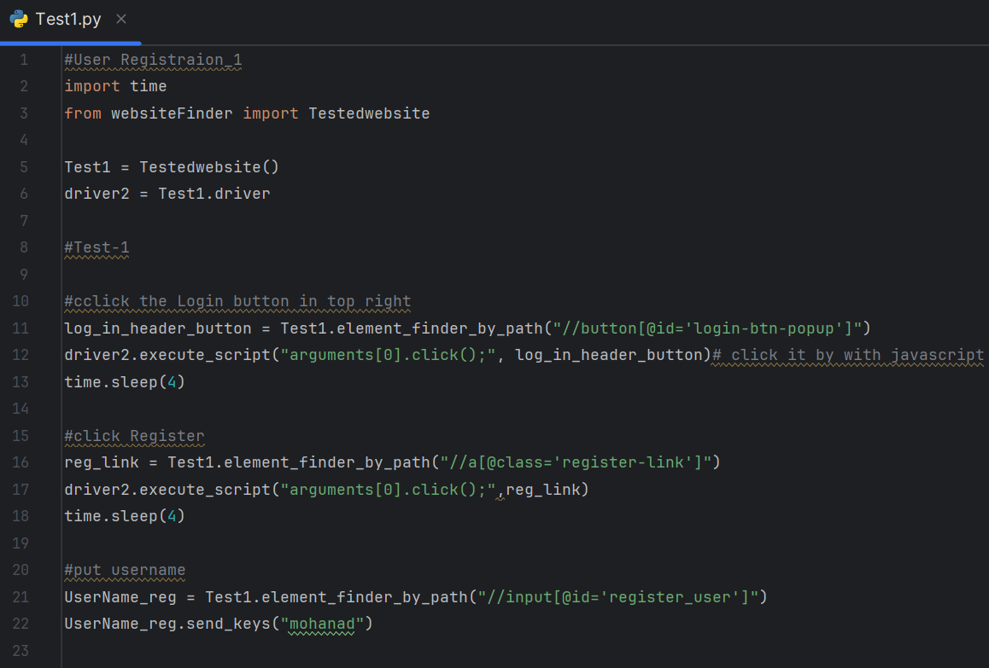

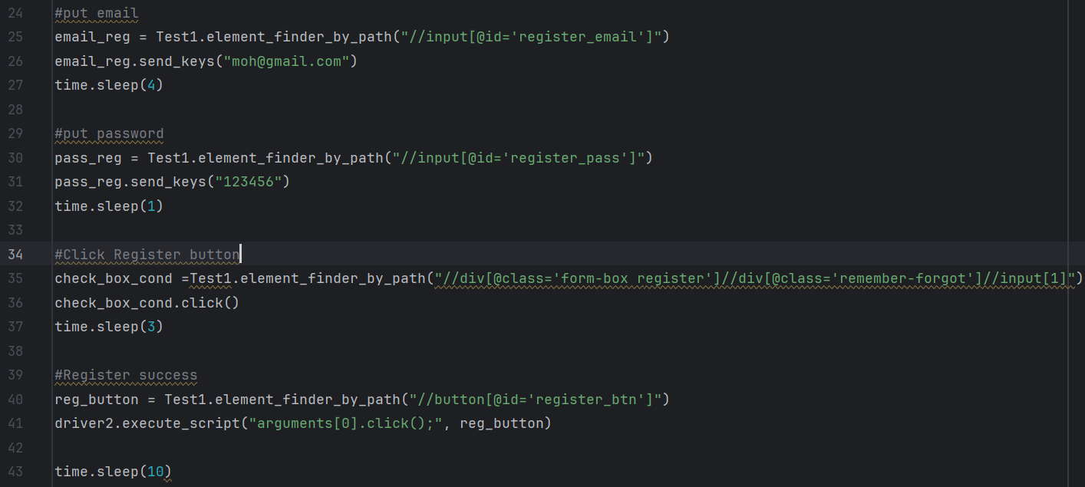



TC_02- User Registraion_2

Attempt to register new user with invalid email or leave the email section empty:

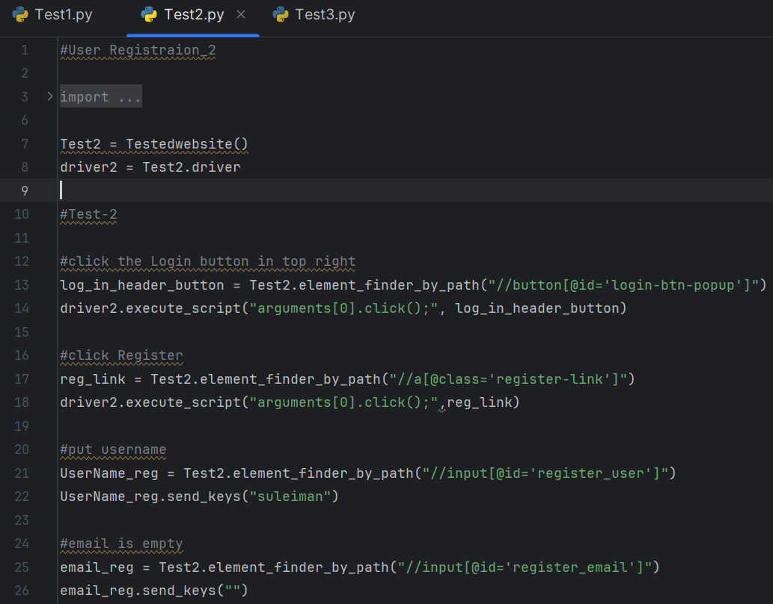

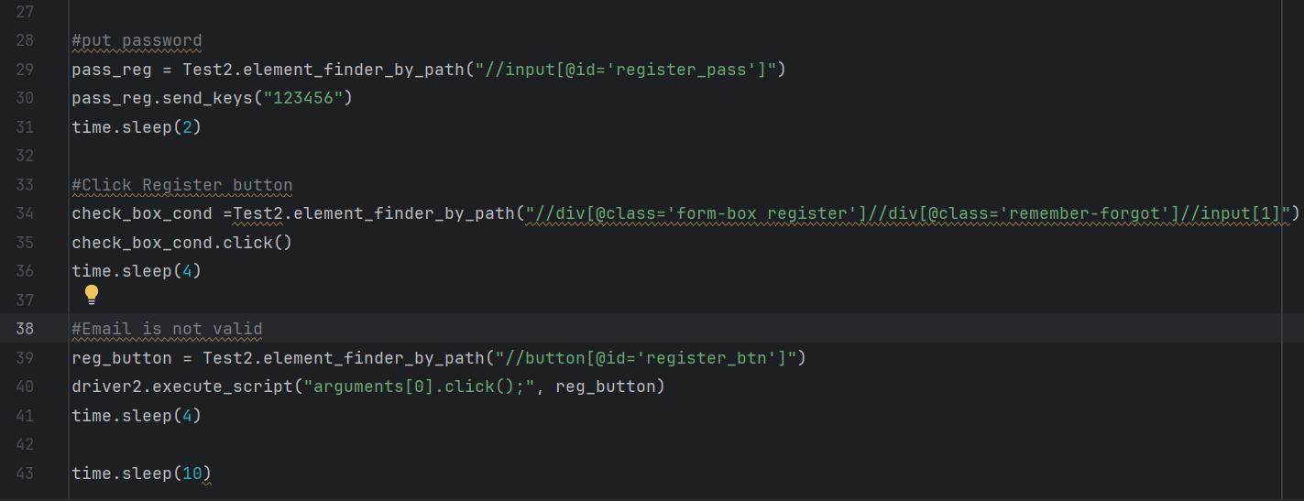

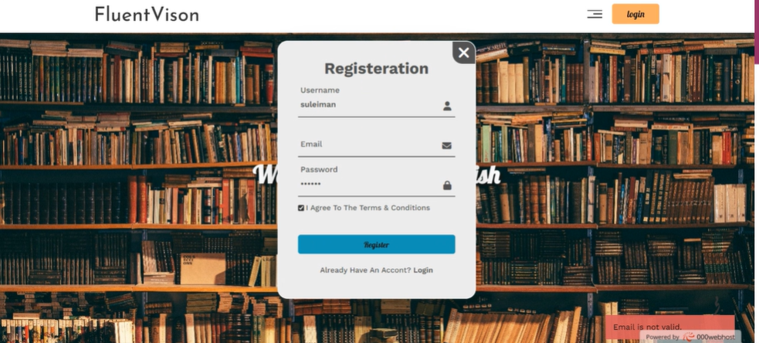

TC_03- User Registraion_3

Attempt to register new user with invalid password or empty password:

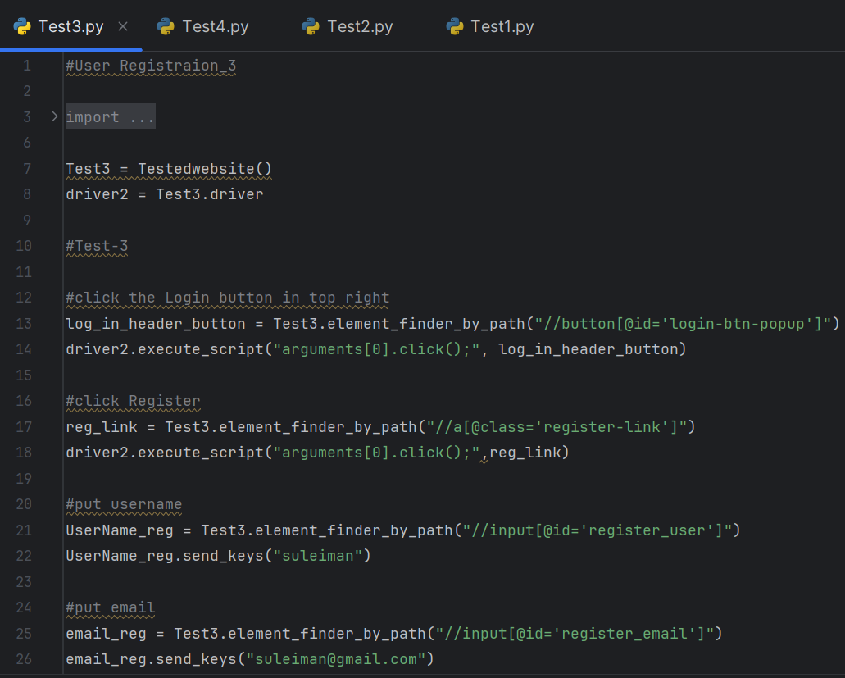

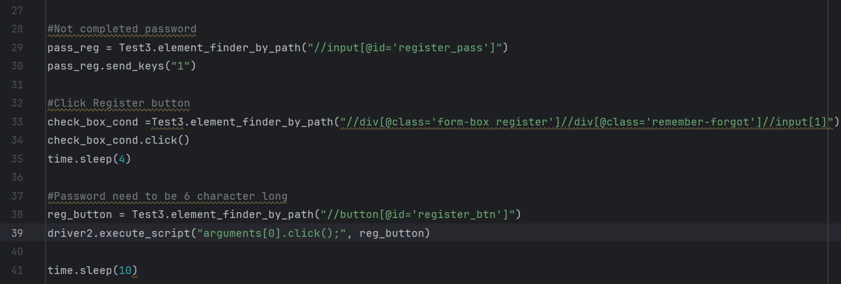

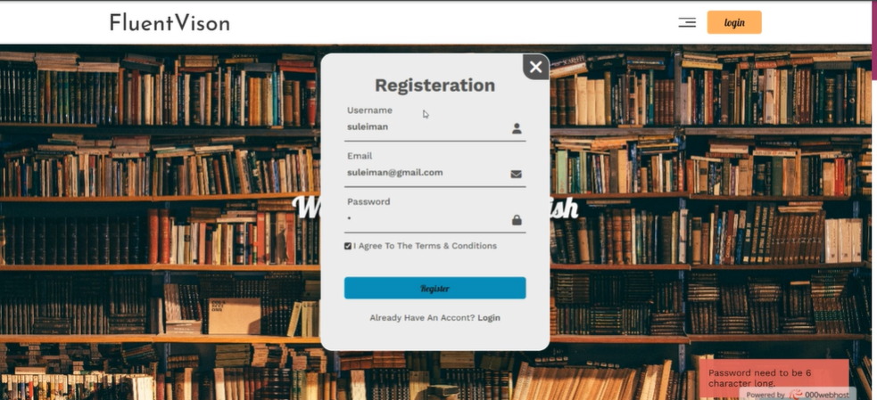

TC_04- User Registraion_4

Attempt to register new user with existing user information:

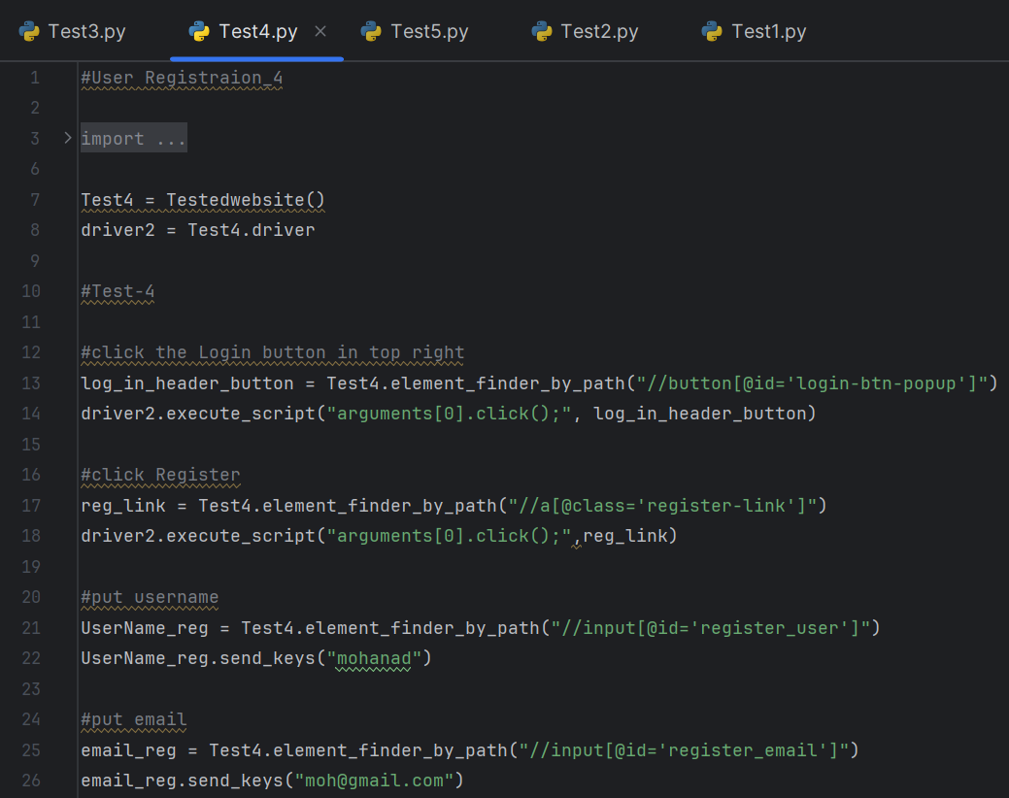

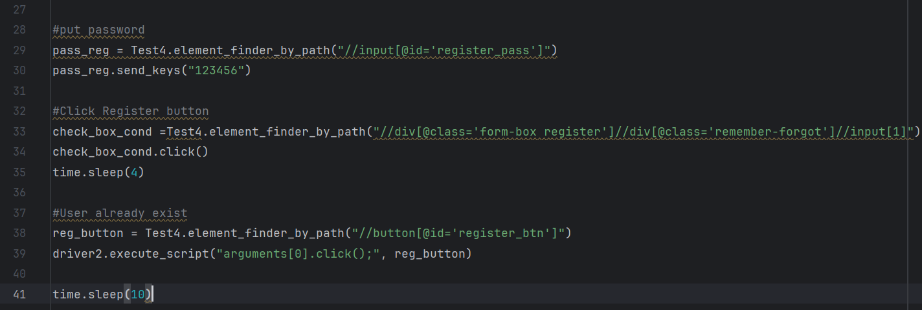

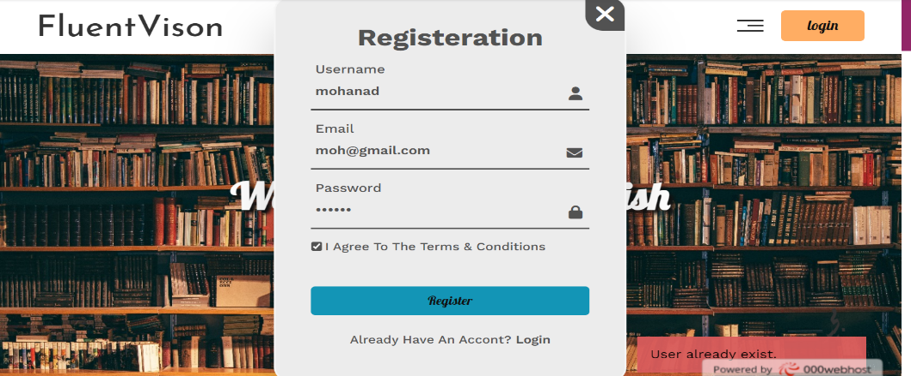

TC_05- User Registration_5

Check if the website will display meaningful error message when the user attempts to press Register when username sections is empty:

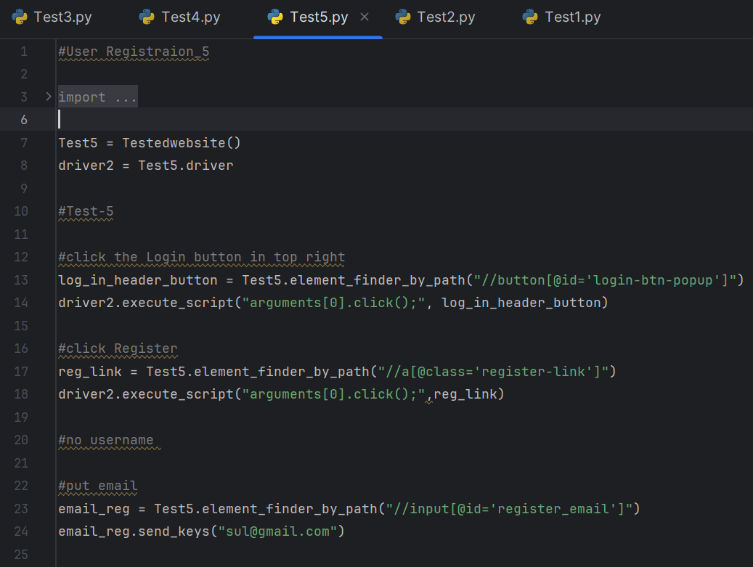

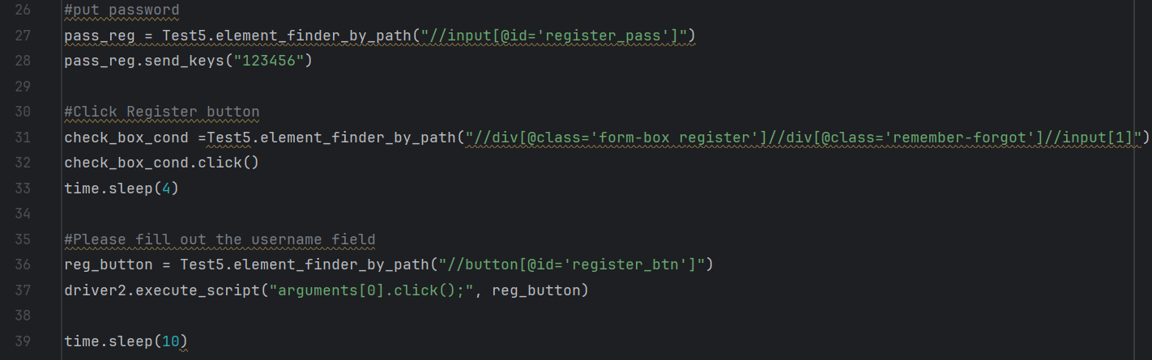

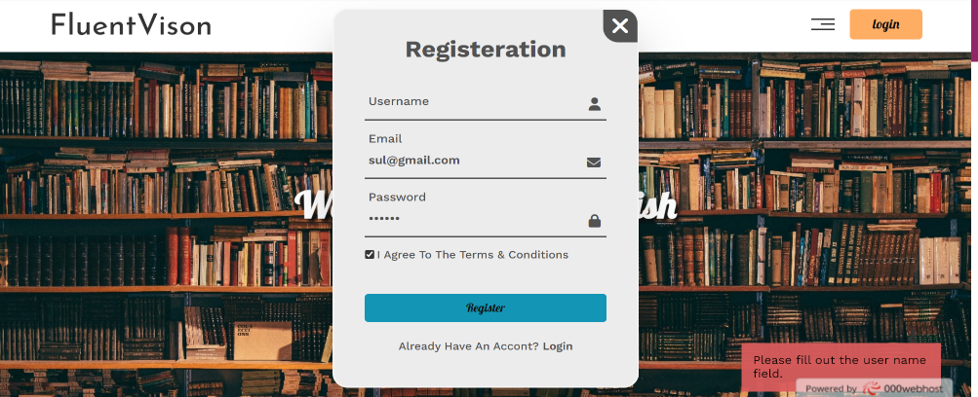

TC_006 User login_1

Attempt to login with valid information:

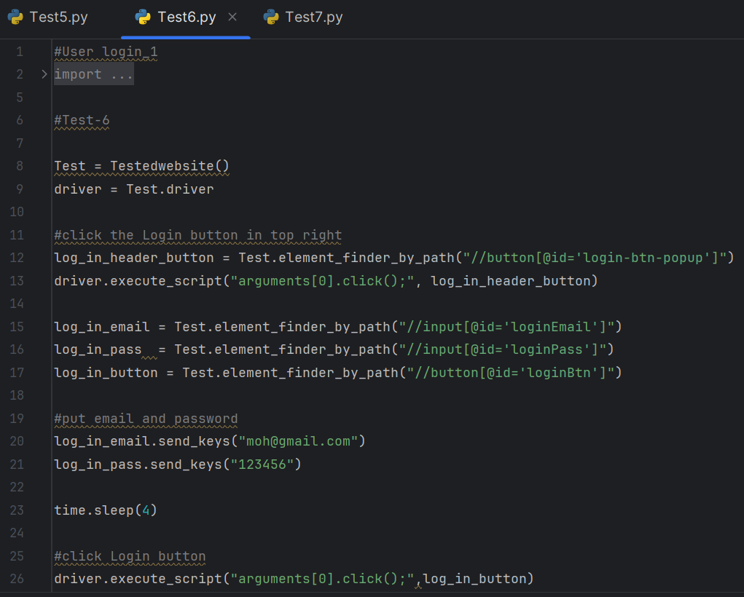



TC_07- User login_2

Attempt to login with invalid email:

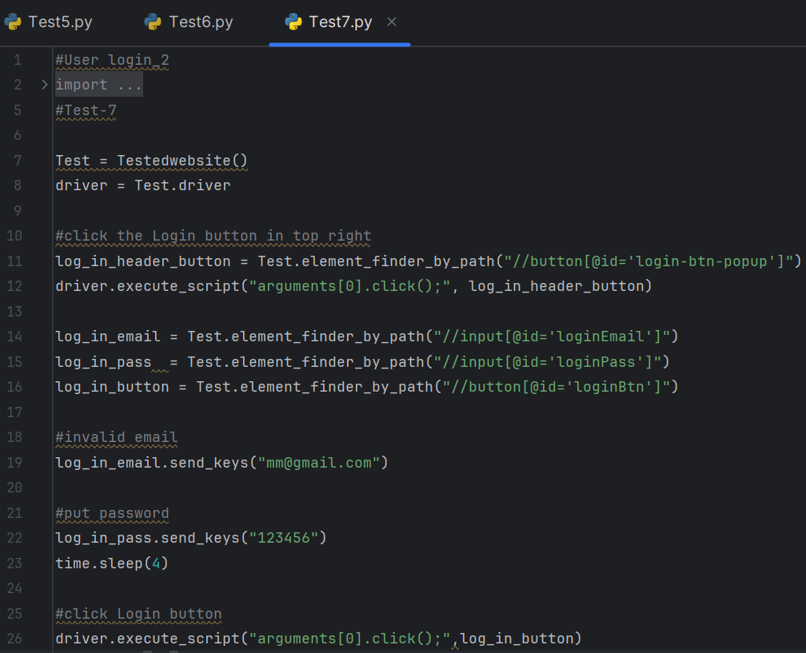

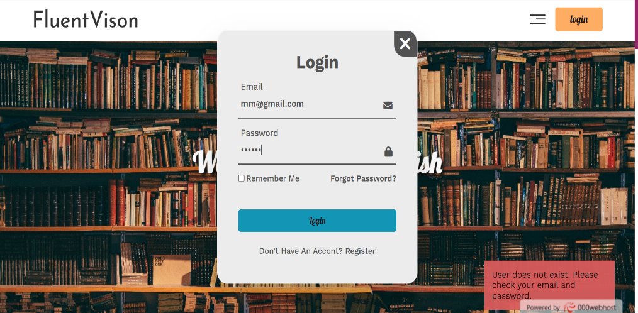

TC_08- User login_3

Attempt to login with invalid password:

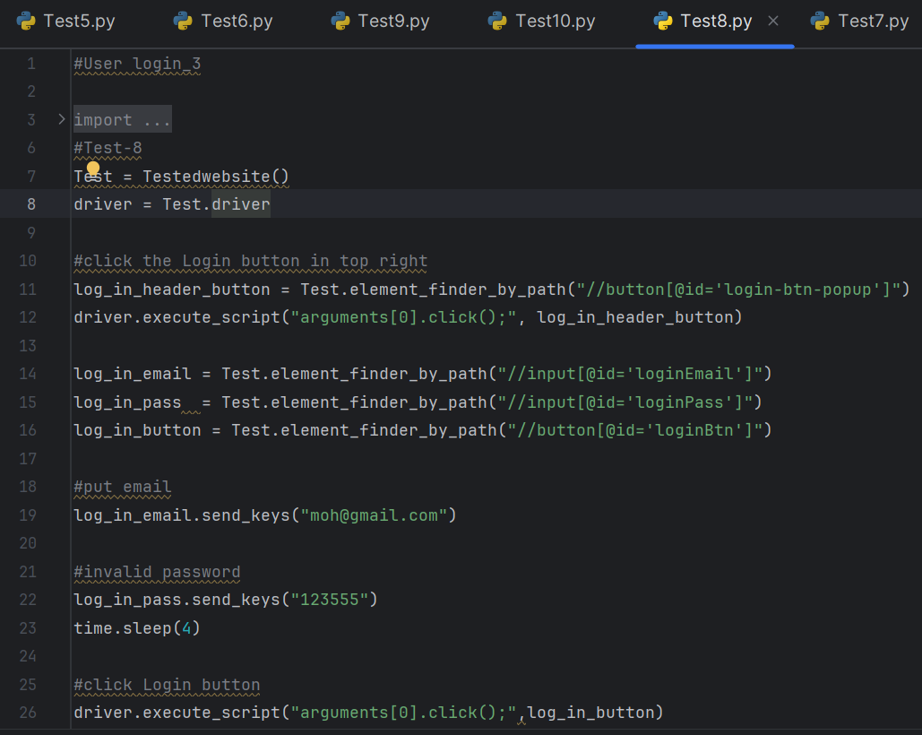



TC_09- User login_4

Attempt to login with non-existing user:

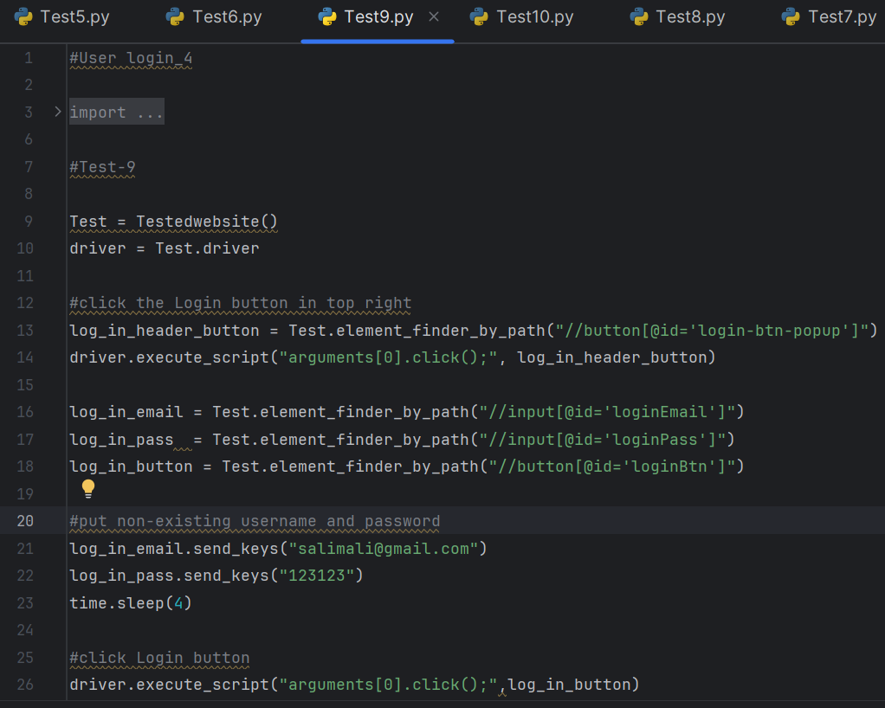

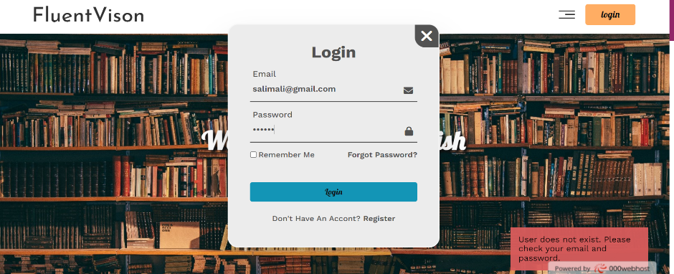

TC_010- login_5

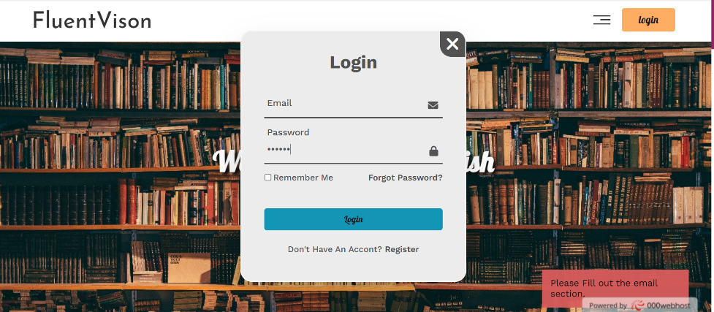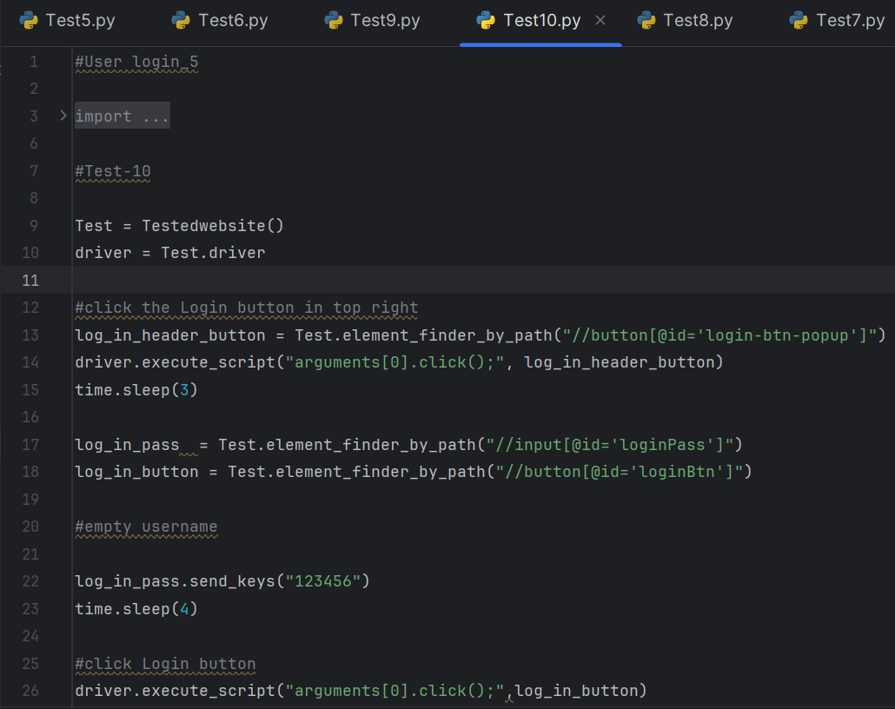Check if the website will display meaningful error message when the user attempts to press login when one of the sections is empty:

TC_011- User profile_1

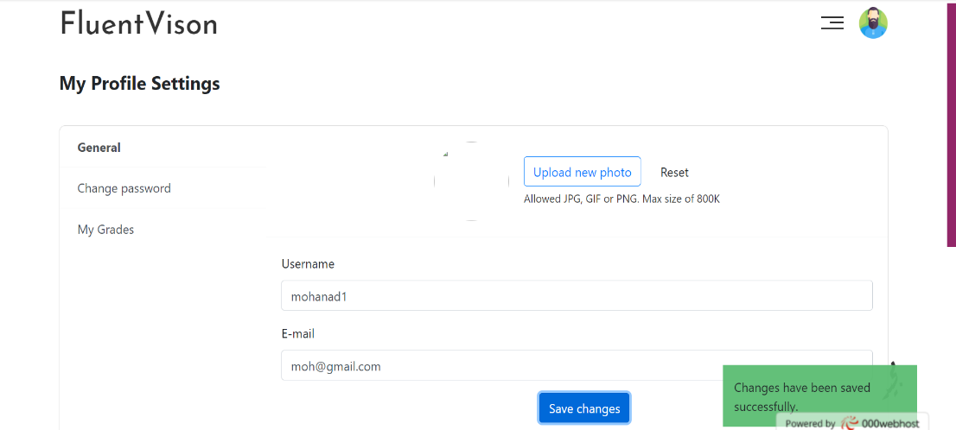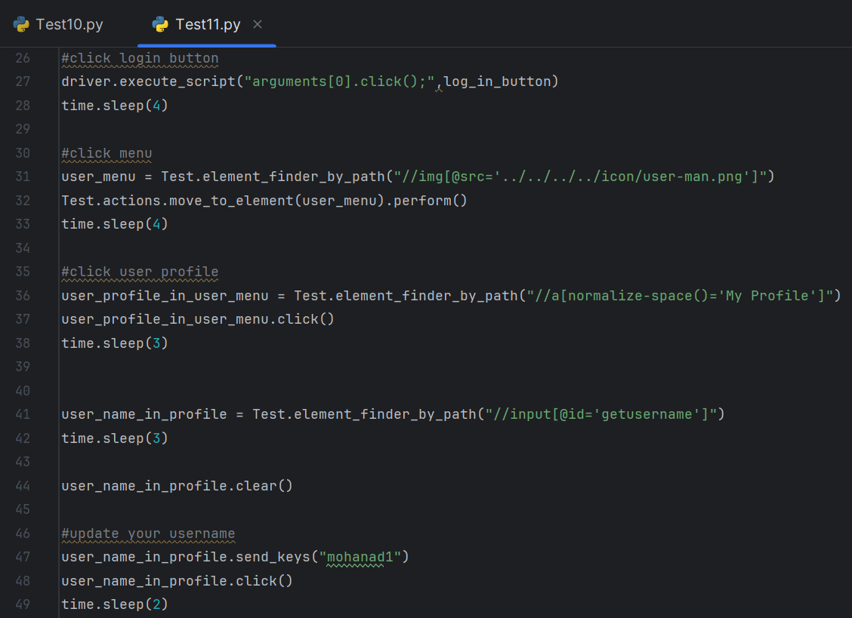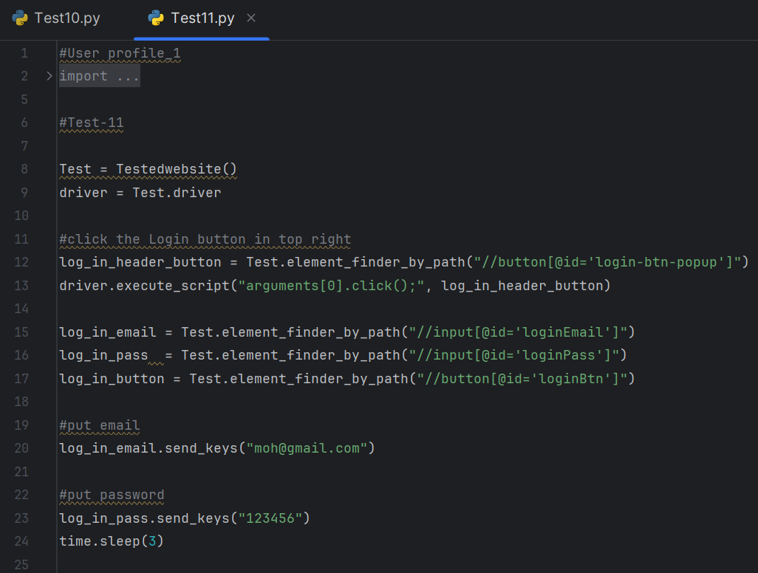Updating the username:

TC_012- User profile_2

Updating the Email:

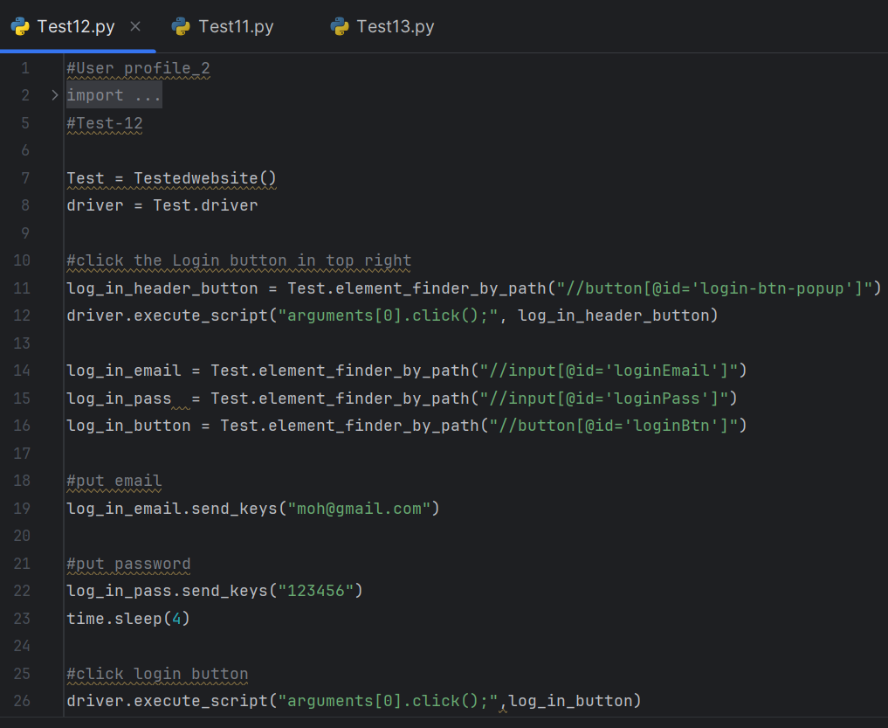

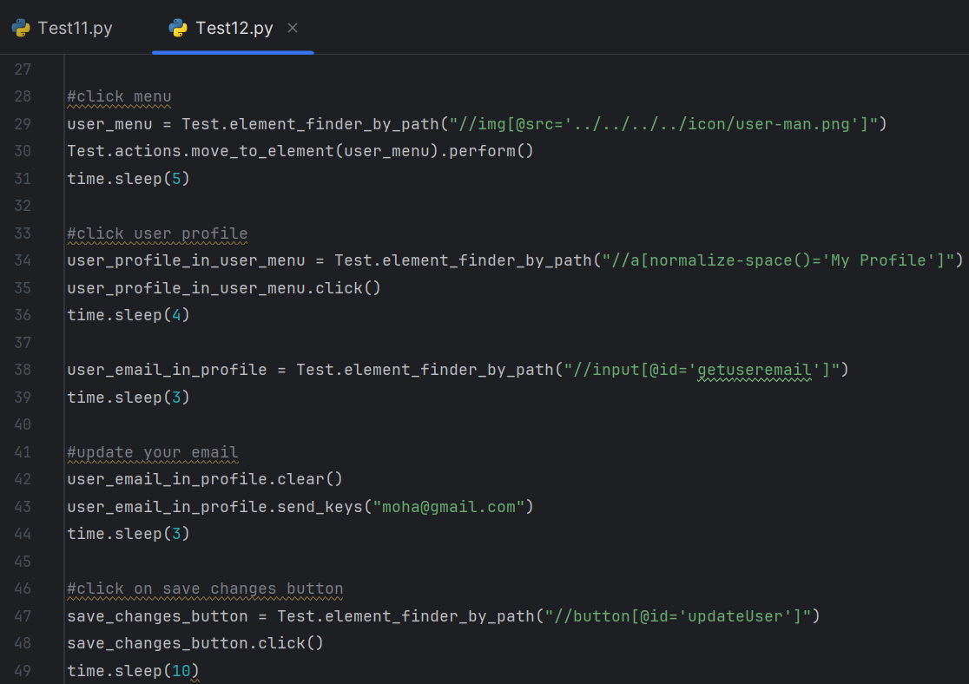

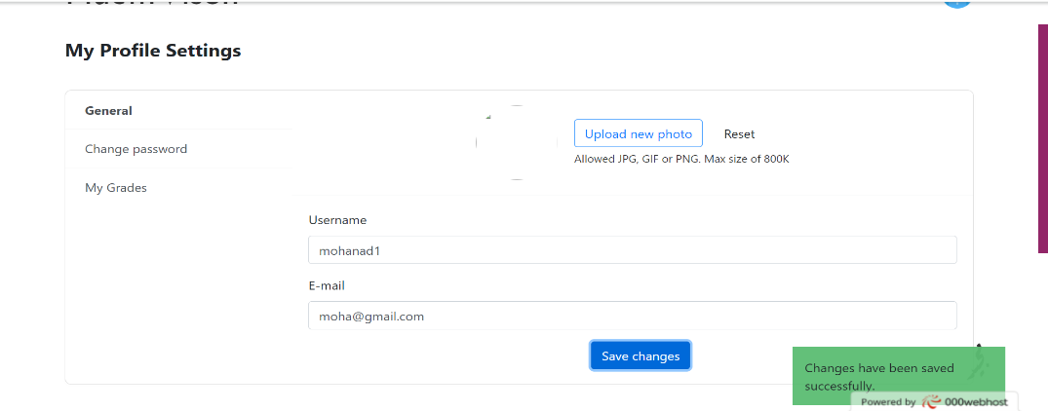

TC_013- User profile_3

Updating the password:

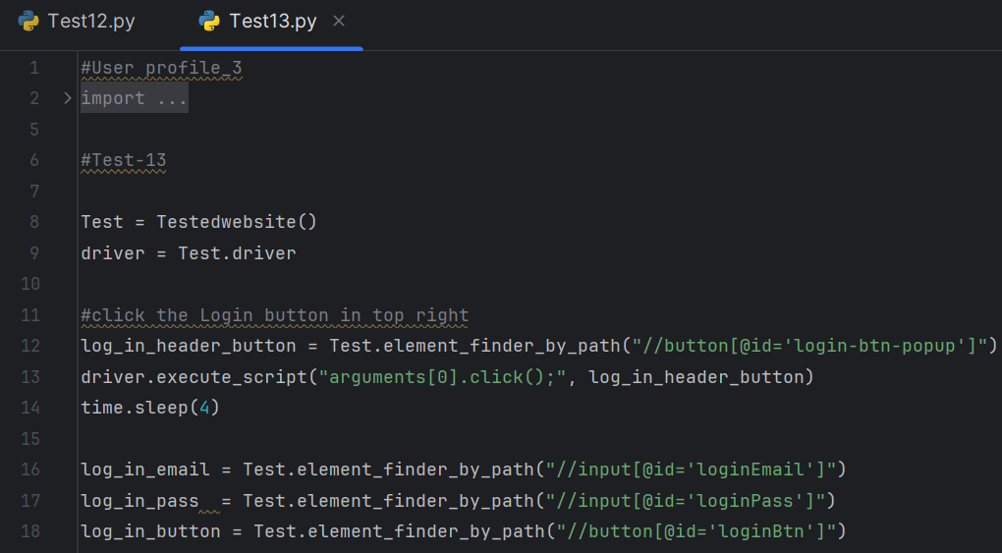

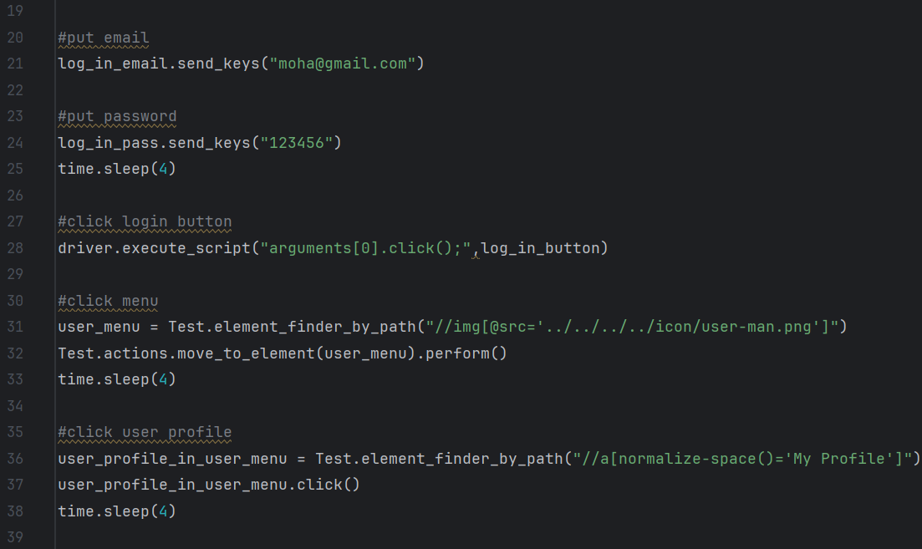

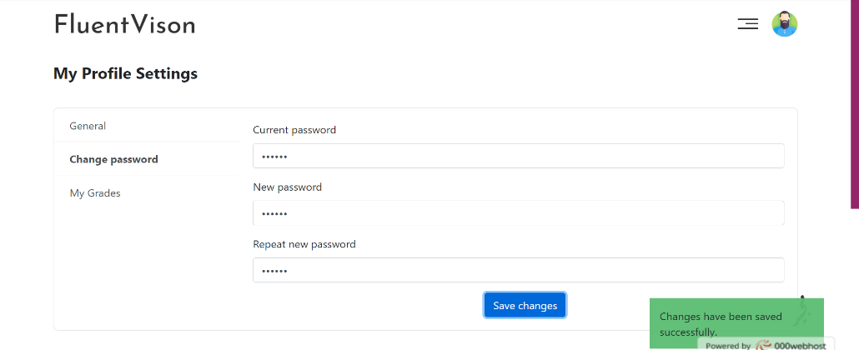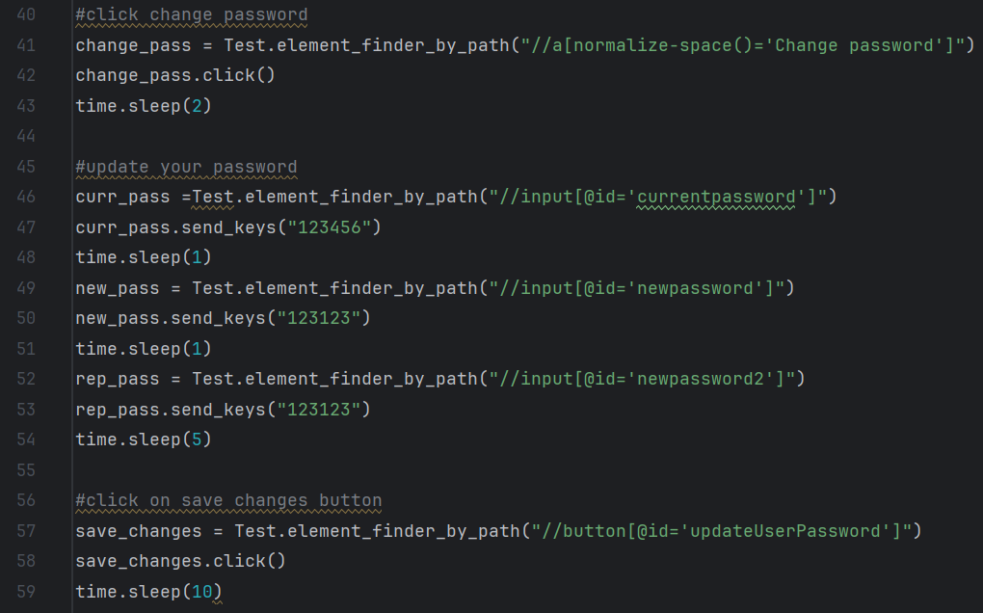

TC_014- User profile_4

updating the username or email section with the same current information:

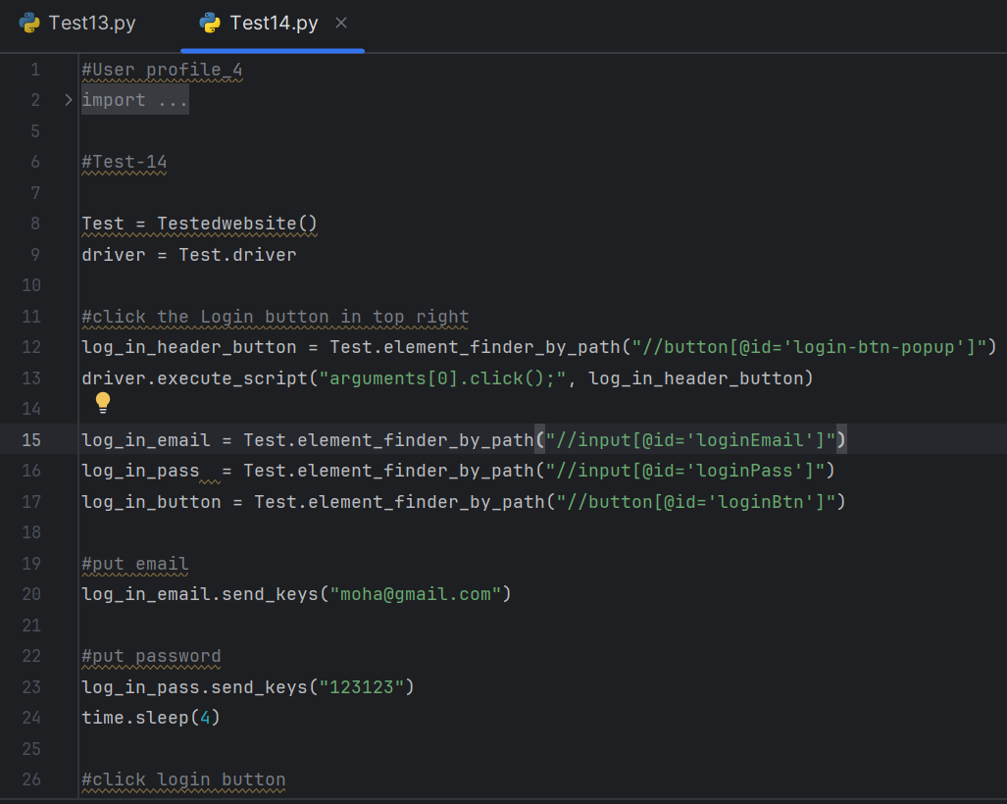

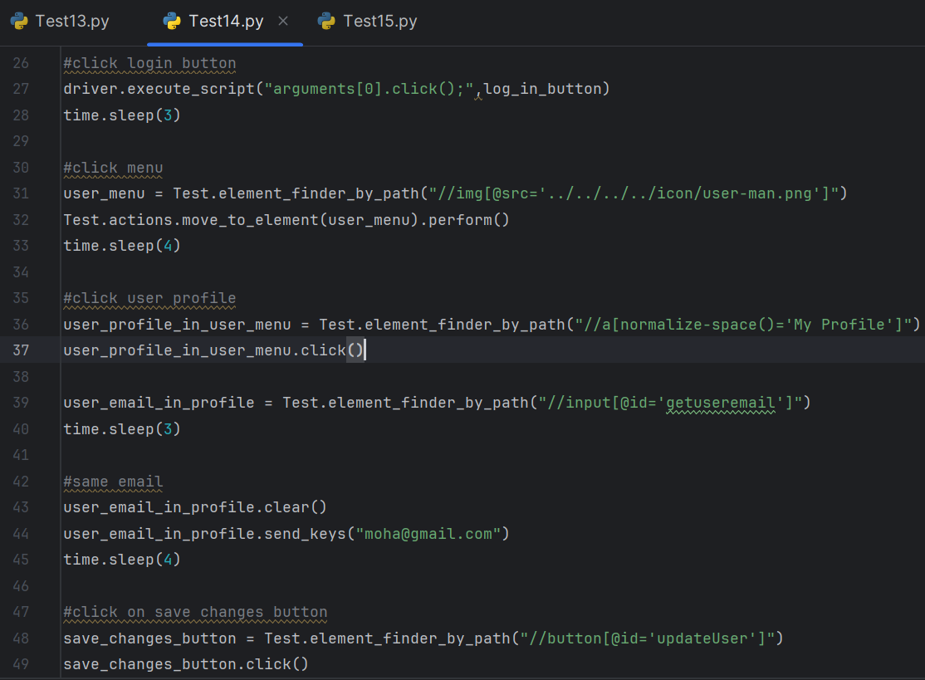

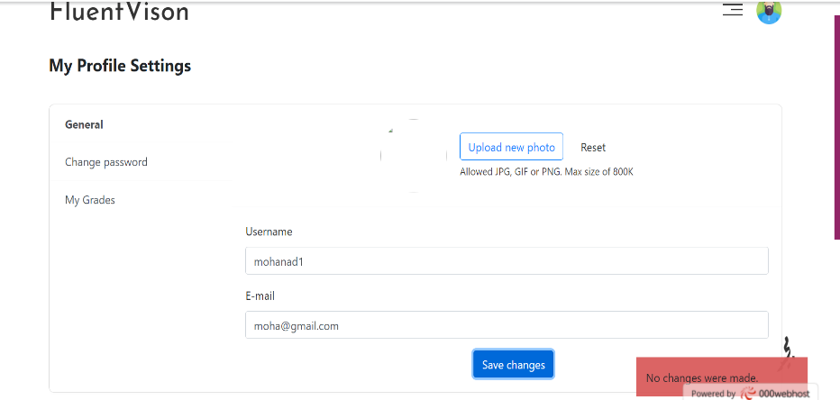

TC_015- User profile_5

Updating the password with the same current password:

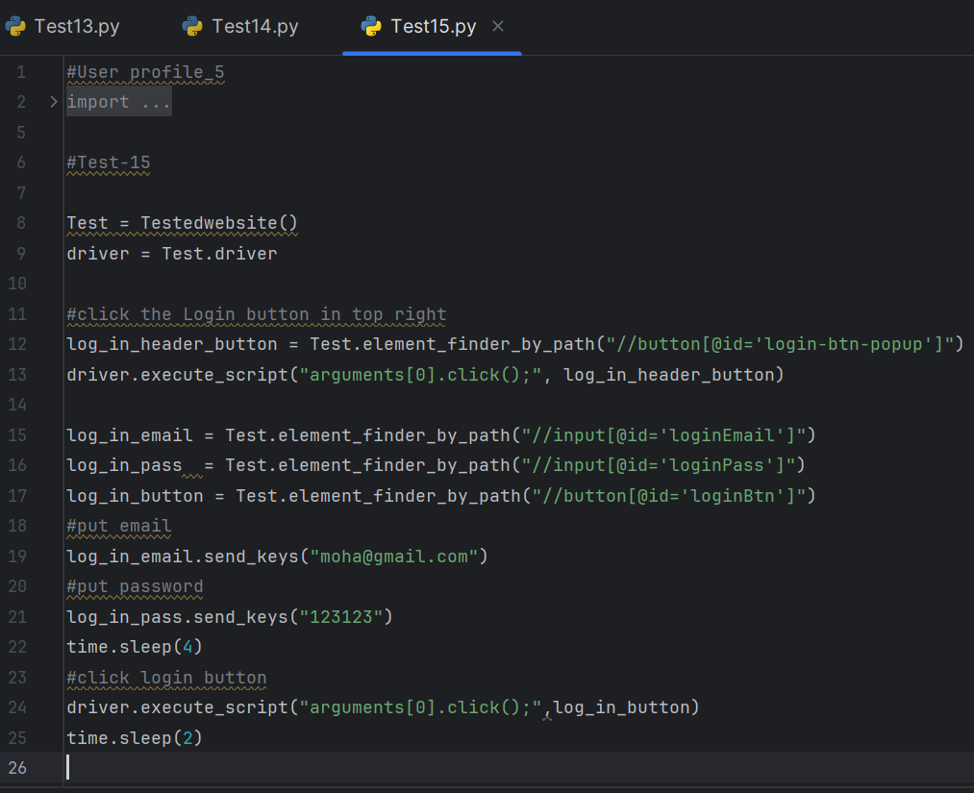

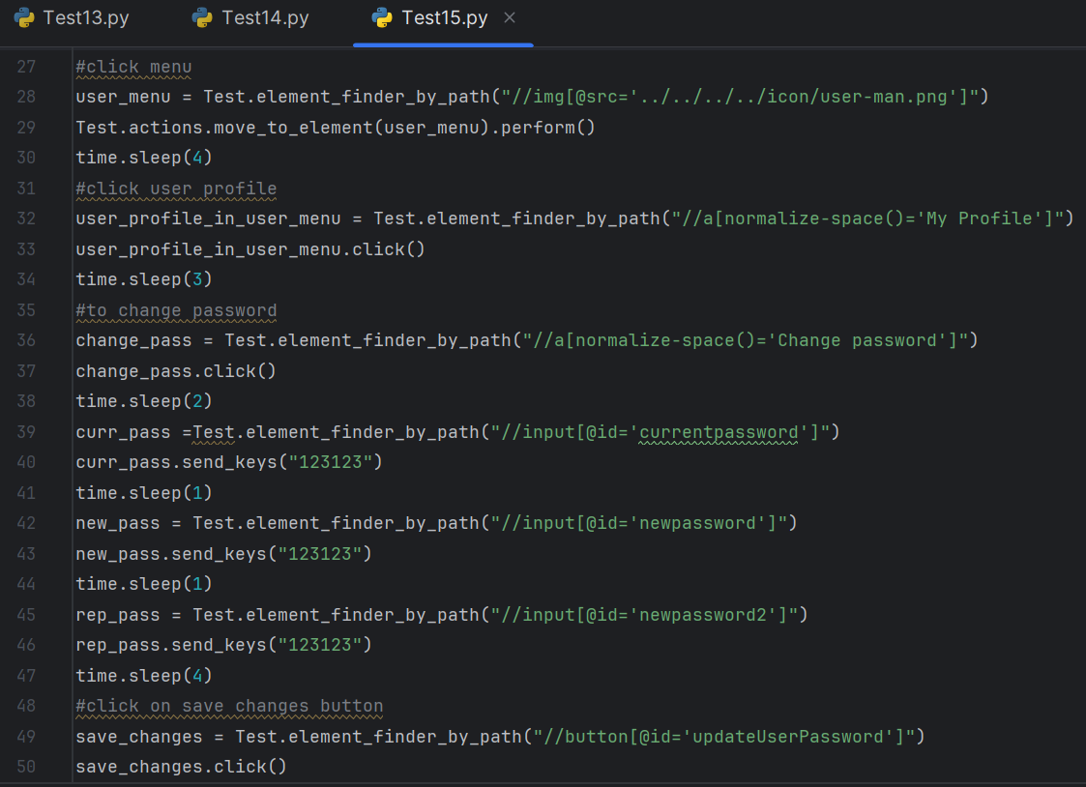

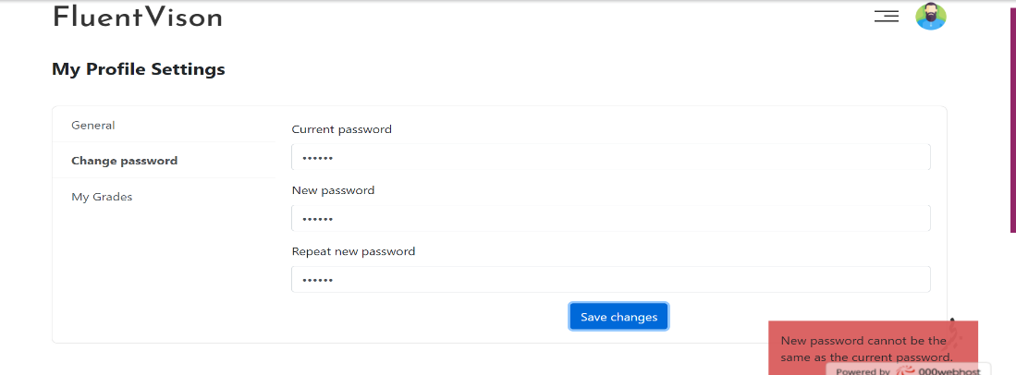

TC_016- User profile_6

Updating the password but the current password and repeat new password section are different:

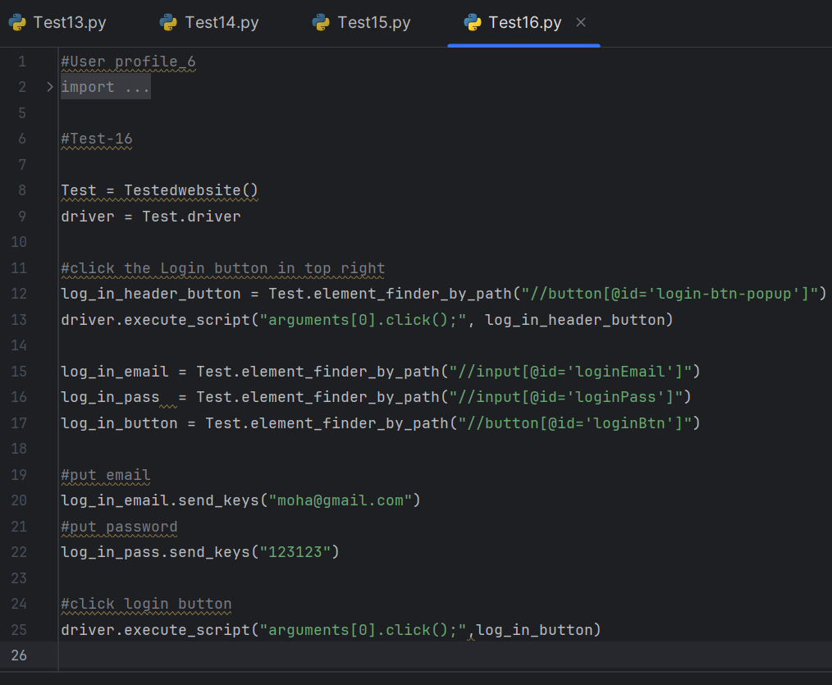

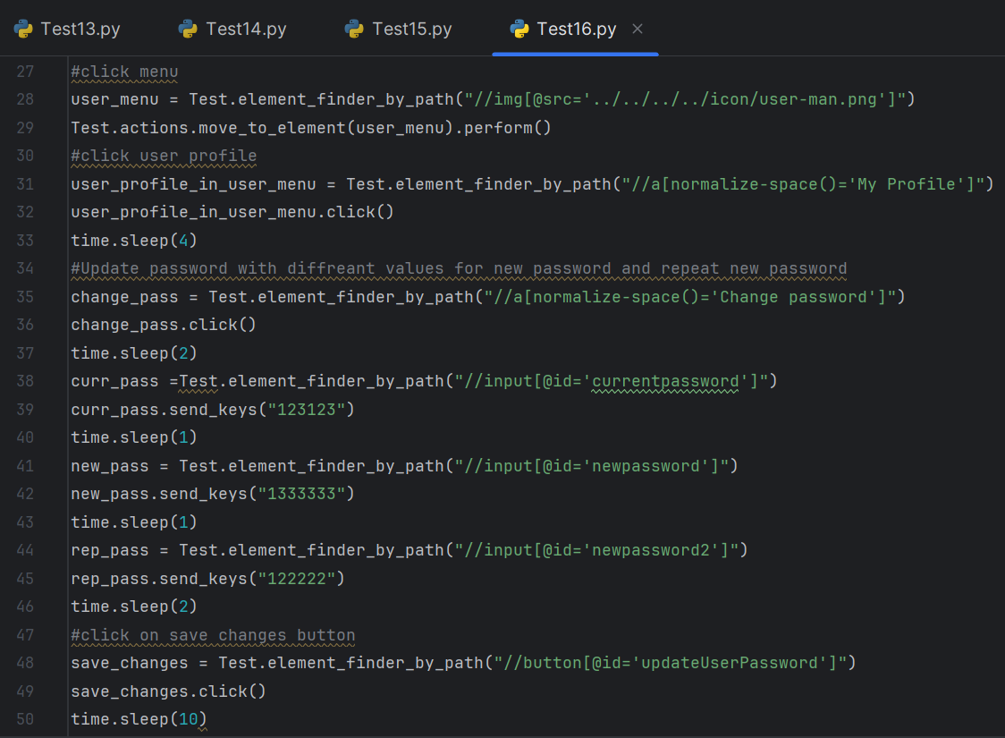

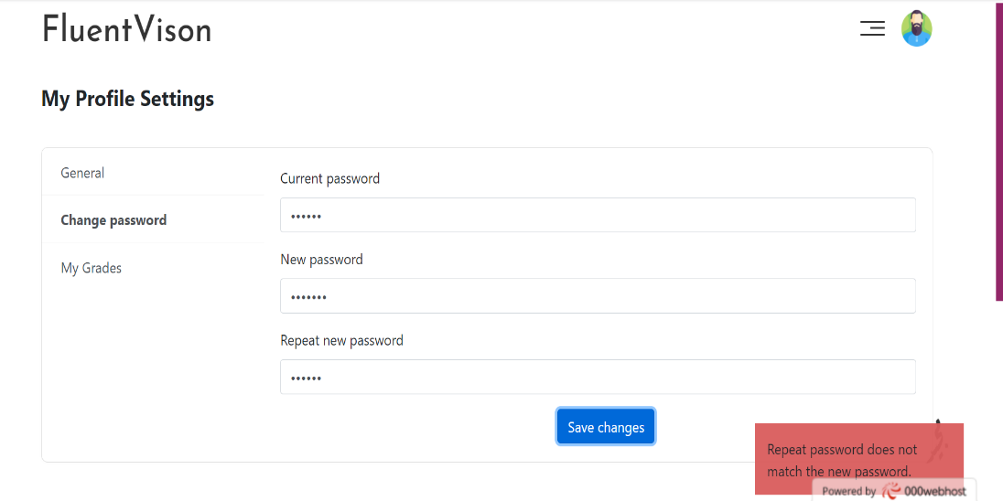

TC_017- User profile_7

Modify the password when one of the fields is blank:

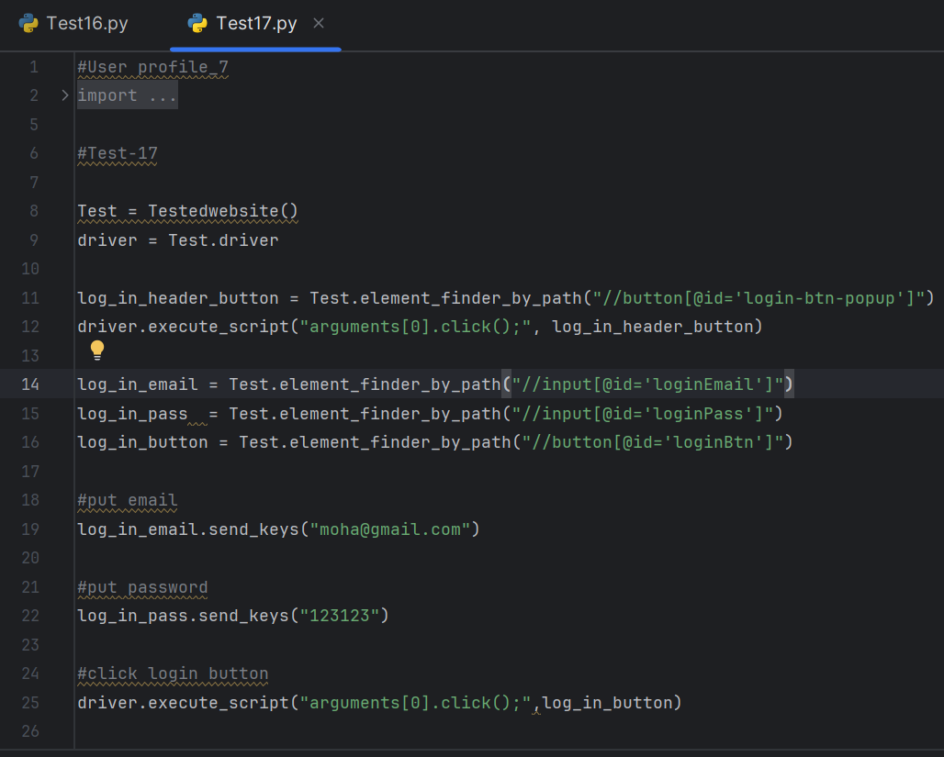

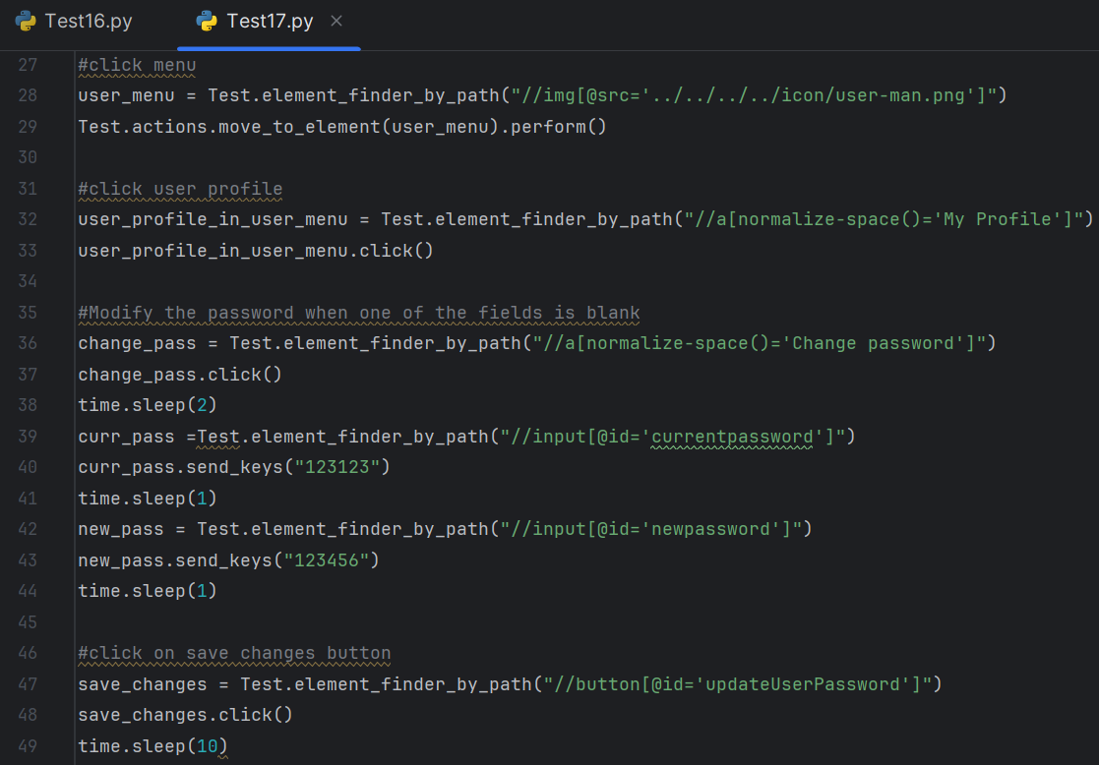

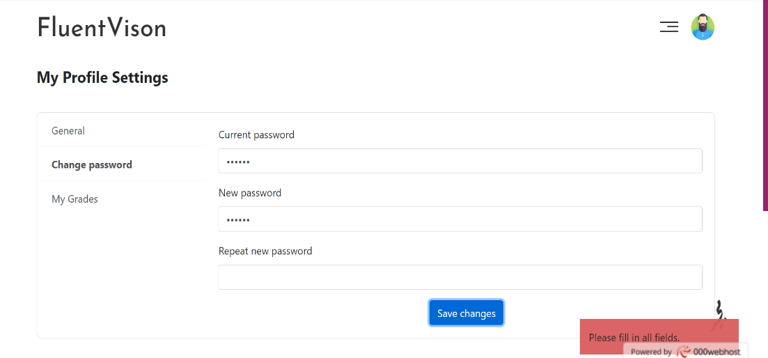

TC_018- Listening_Audio

Starting the audio:

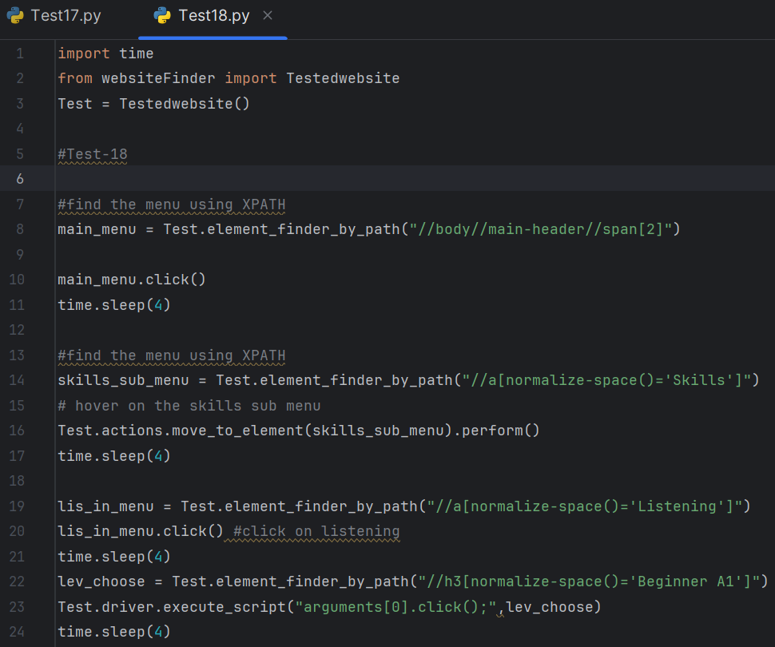

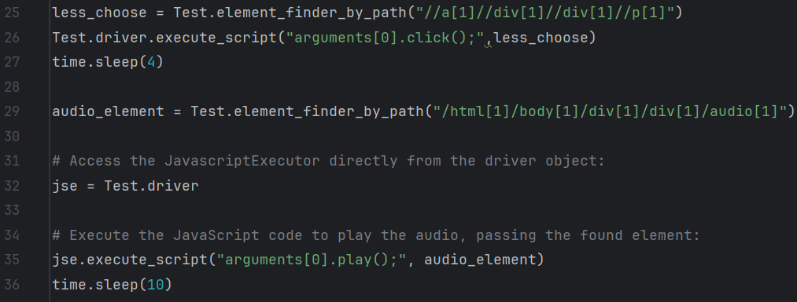

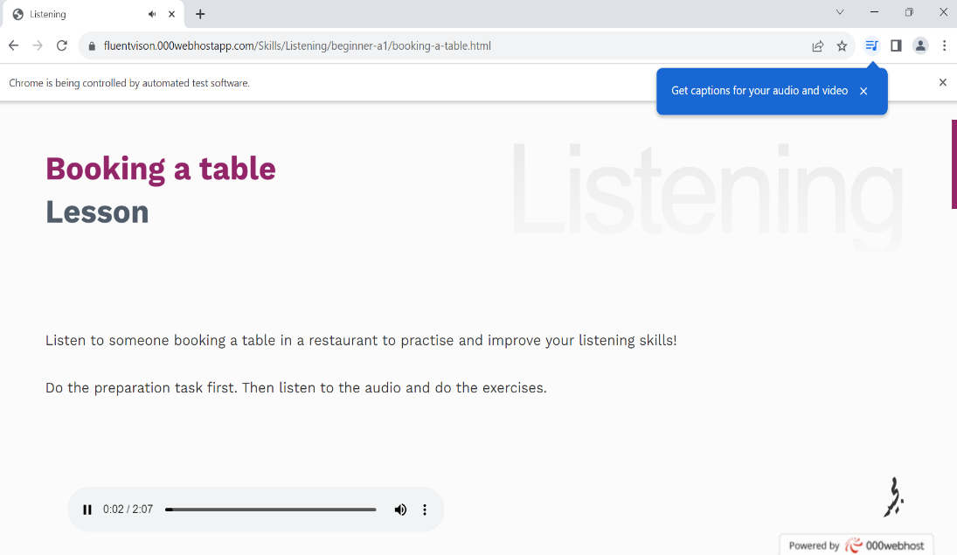

TC_019- Speaking_Video

Starting the Video:

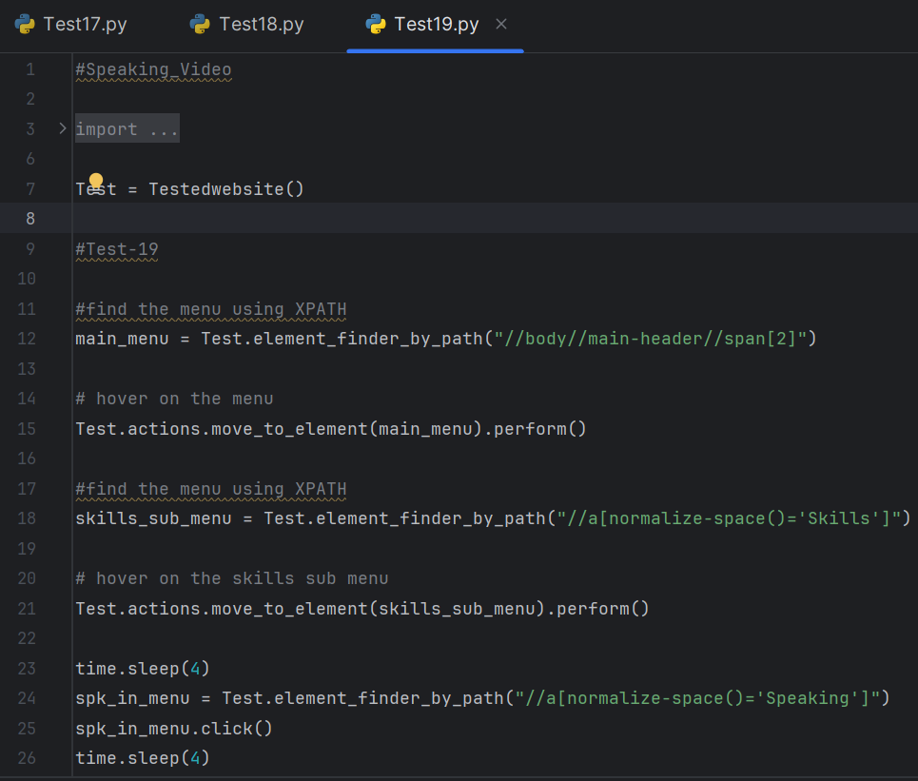

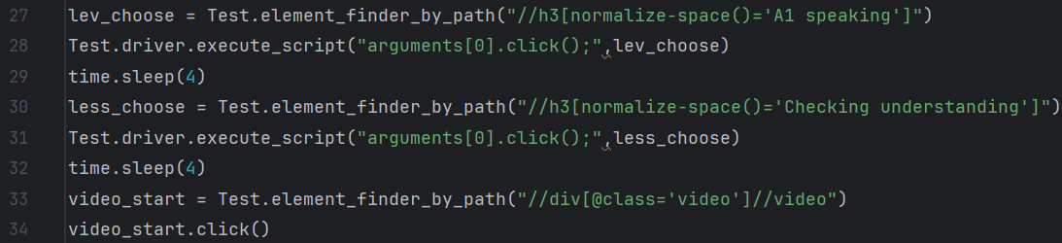

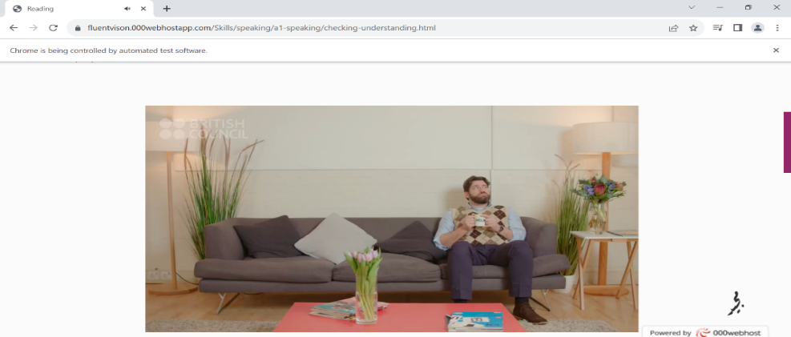

TC_020- Reading_Text

Checking if the text size, color, format is in correct form:

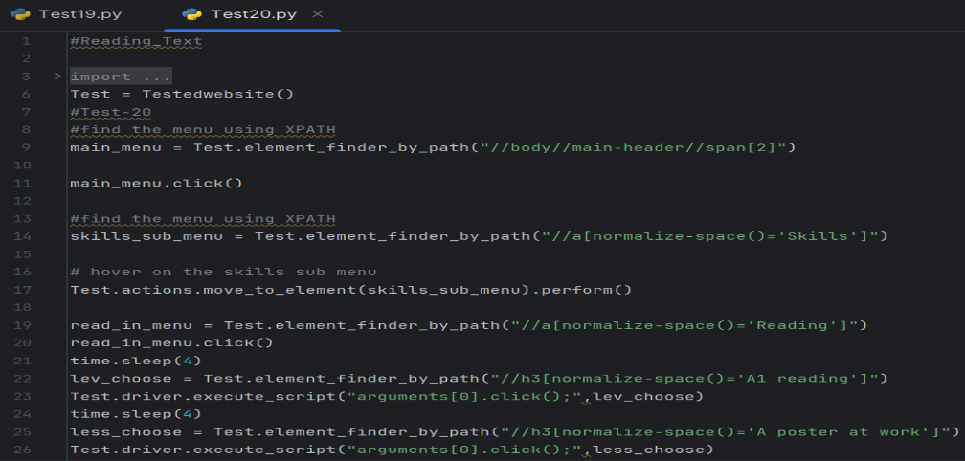

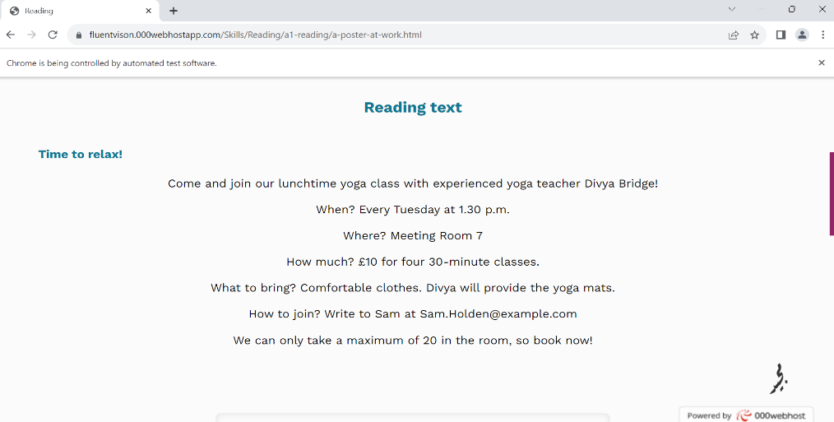

TC_021- Quiz_1

check if the website will evaluate the user answers and determine of it's true, false / also displaying the

number, percentage of the user correct answers:

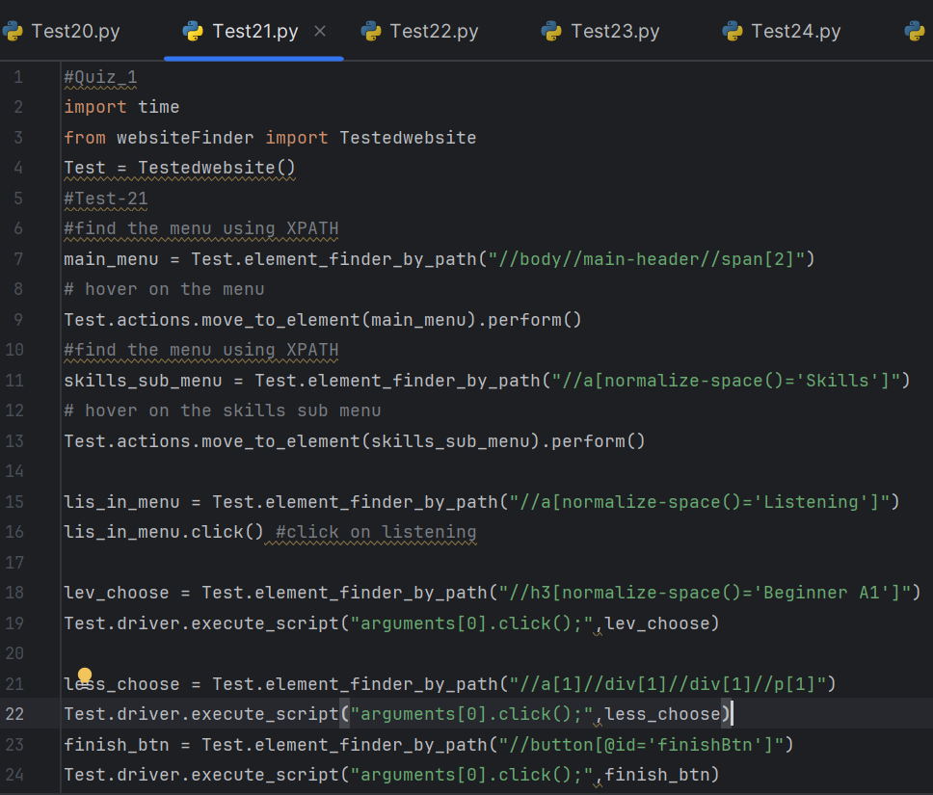

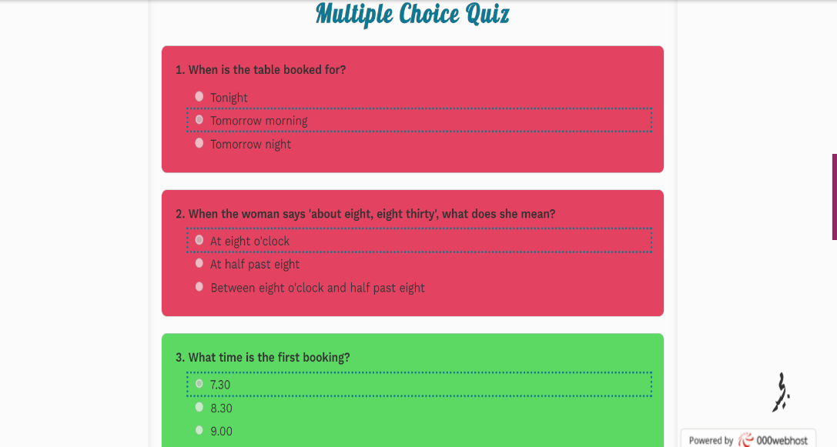

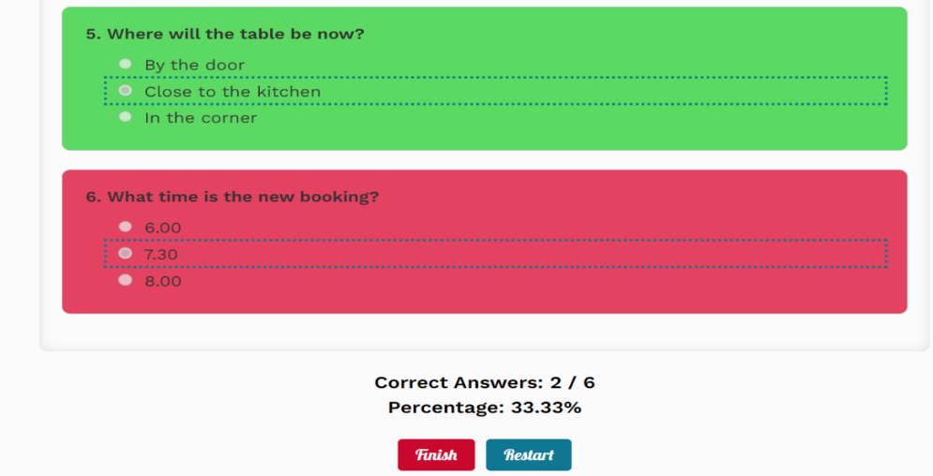

TC_022- Quiz_2

check if the website will evaluate the user answers and determine of it's true, false / also displaying the

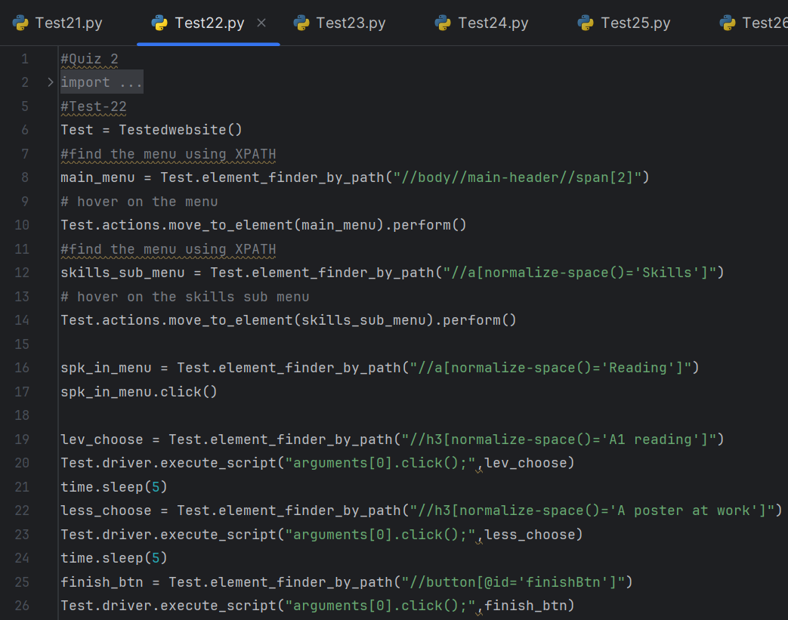number, percentage of the user correct answers:

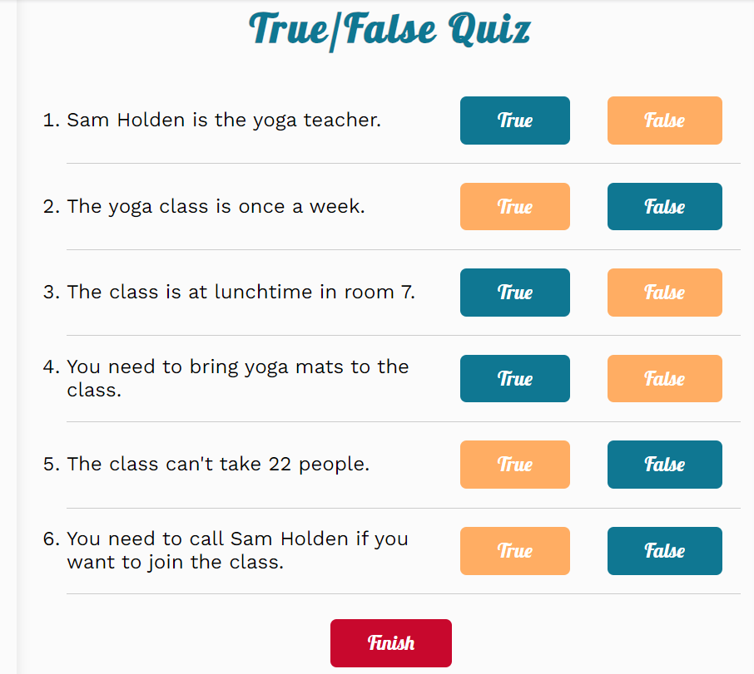

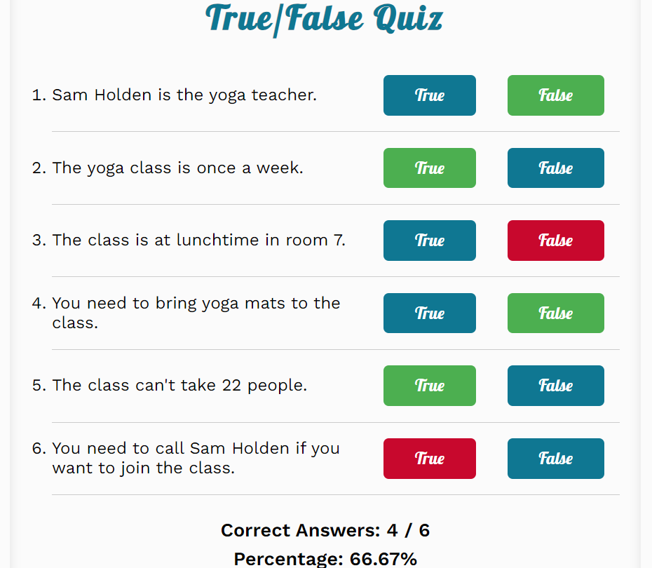

TC_023- Quiz_3

check if the website will evaluate the user answers and determine of it's true, false / also displaying the

number, percentage of the user correct answers:

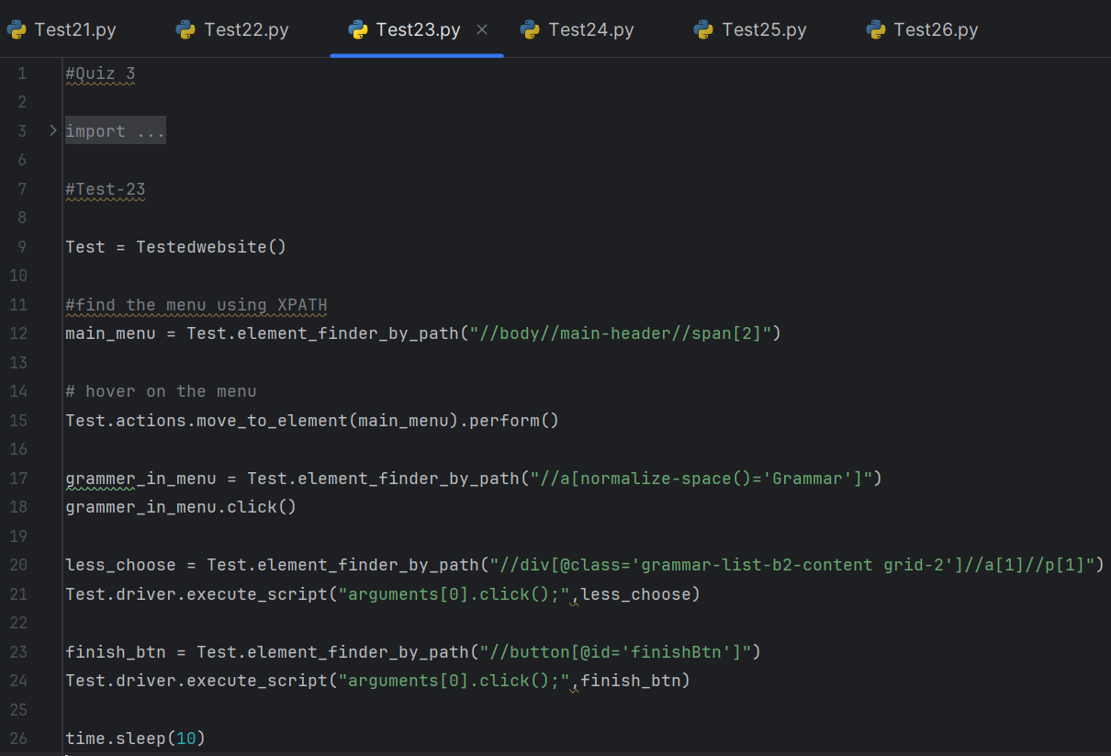

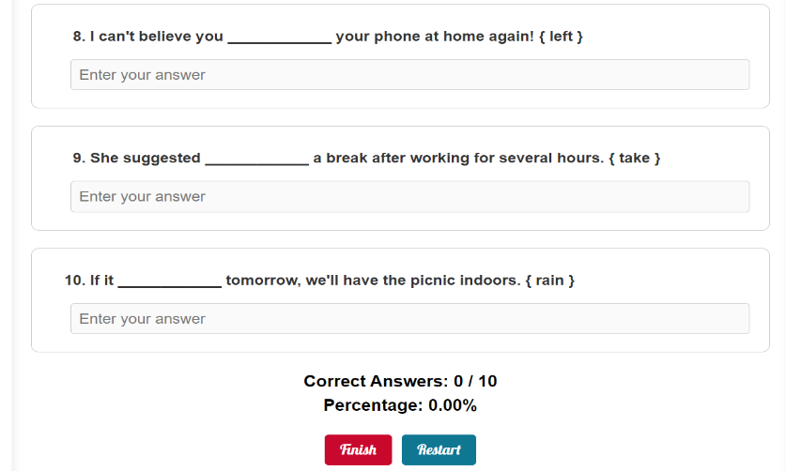

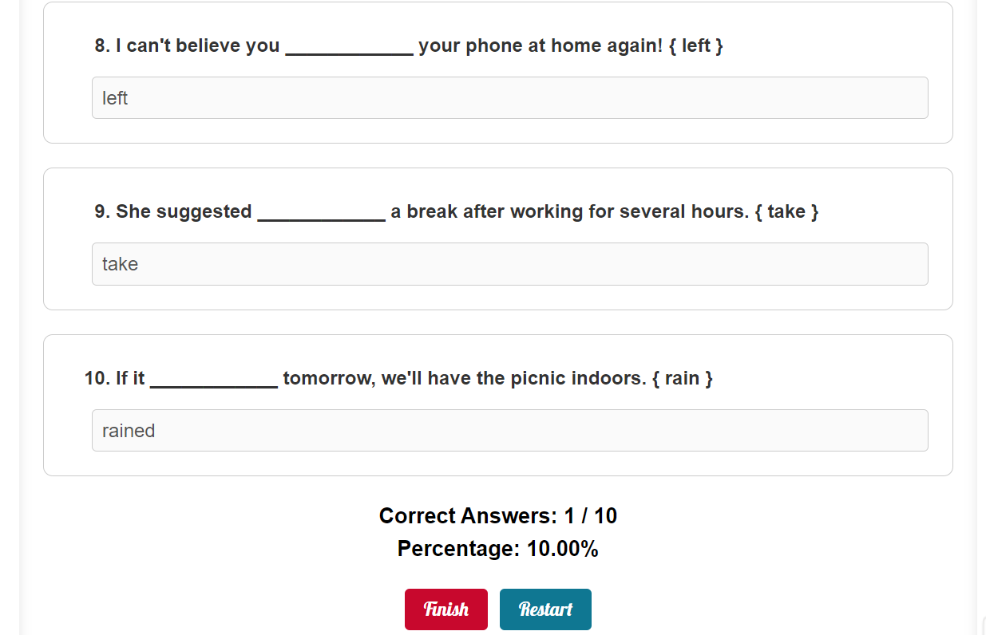

TC_024- Quiz_4

check if the user can click or choose the answer after he press the finish button:

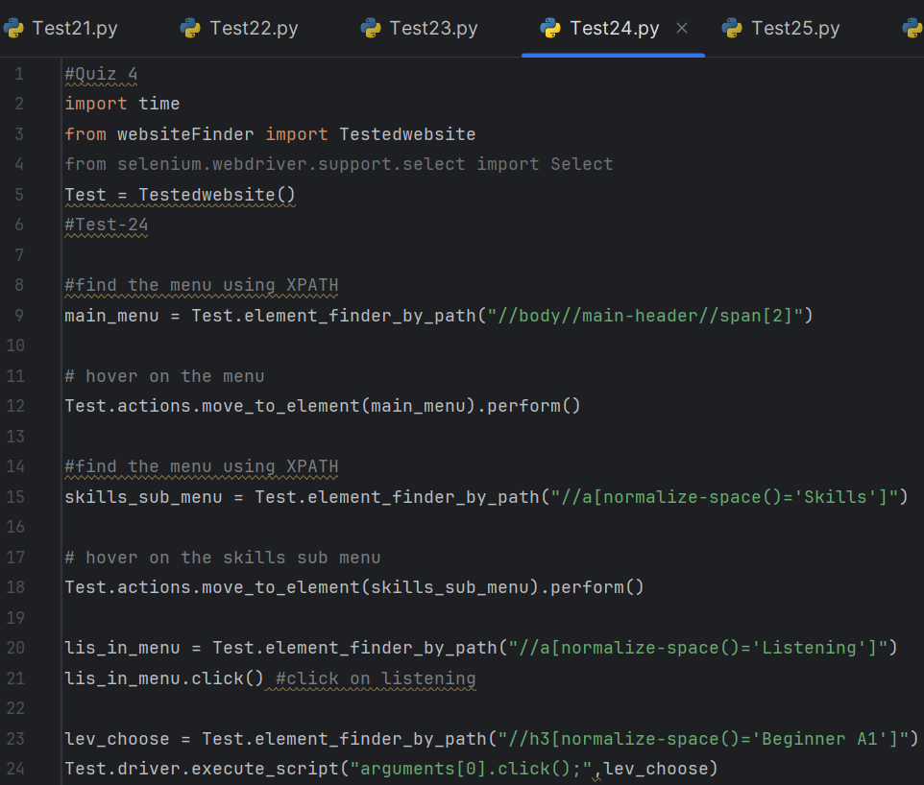

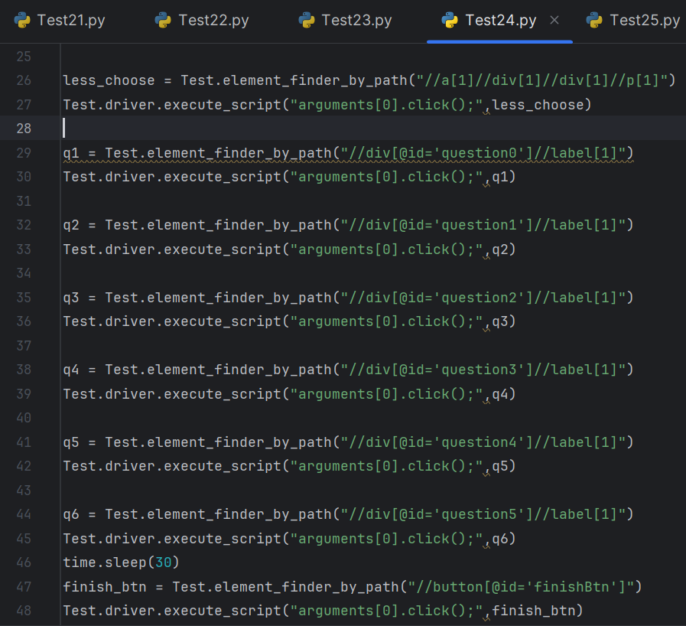

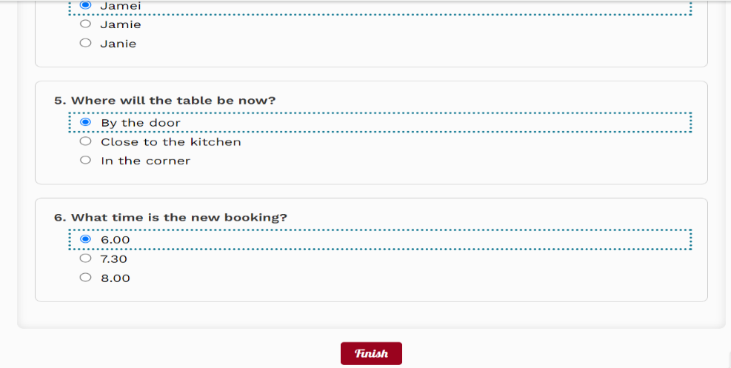

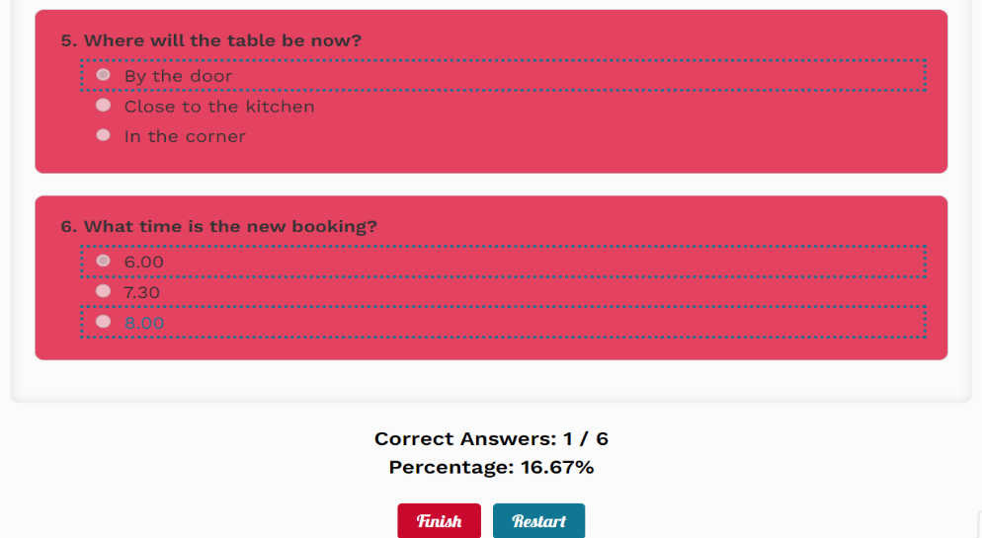

TC_025- Quiz_5

check if the website allows the user to retake the test after he press restart button:

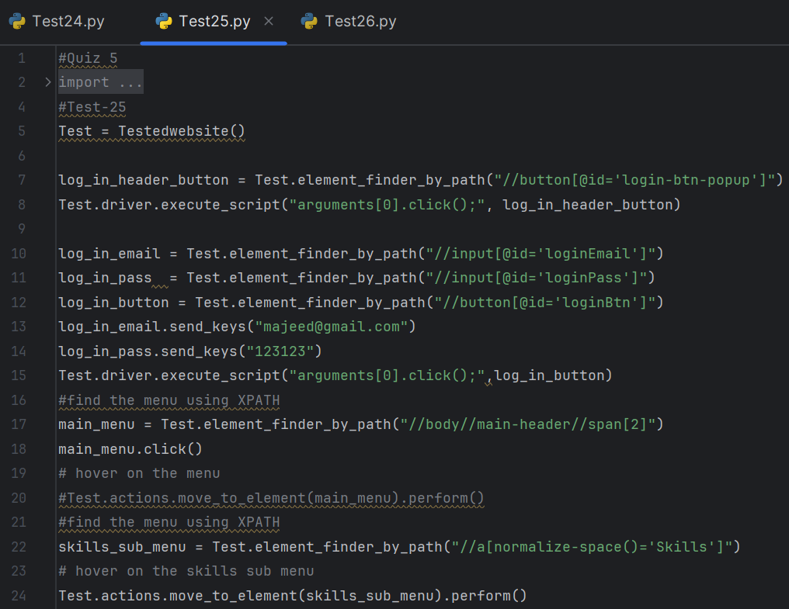

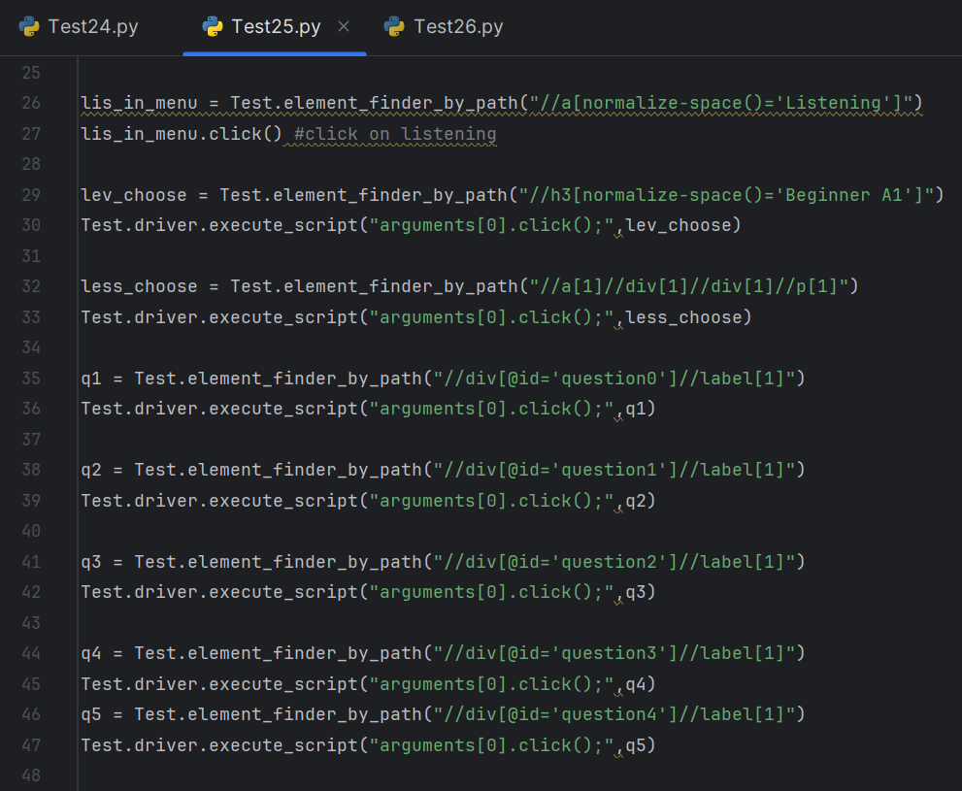

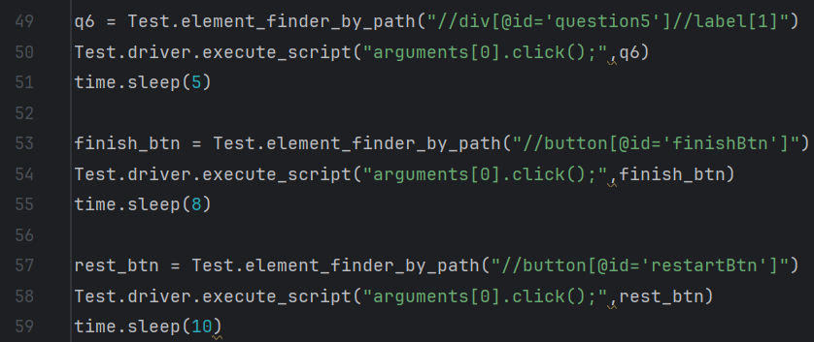

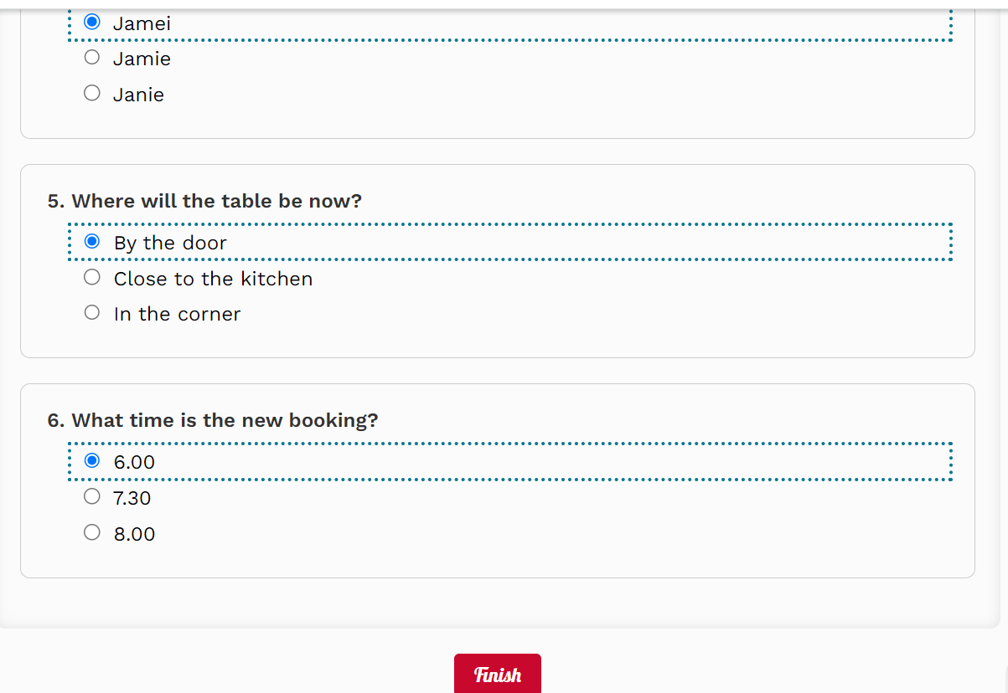

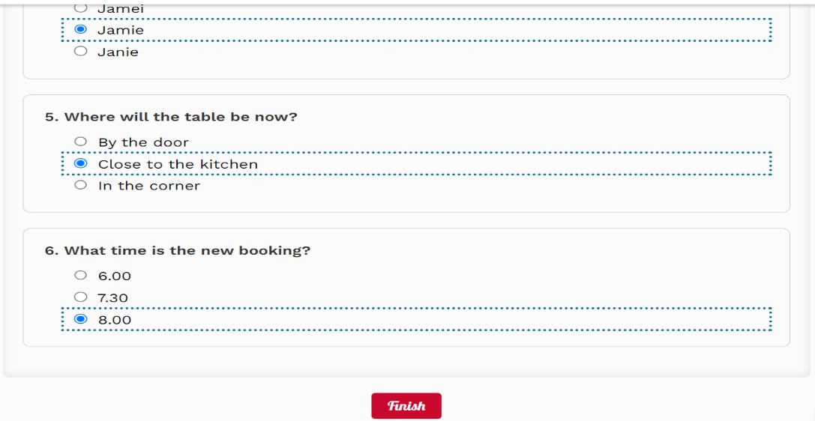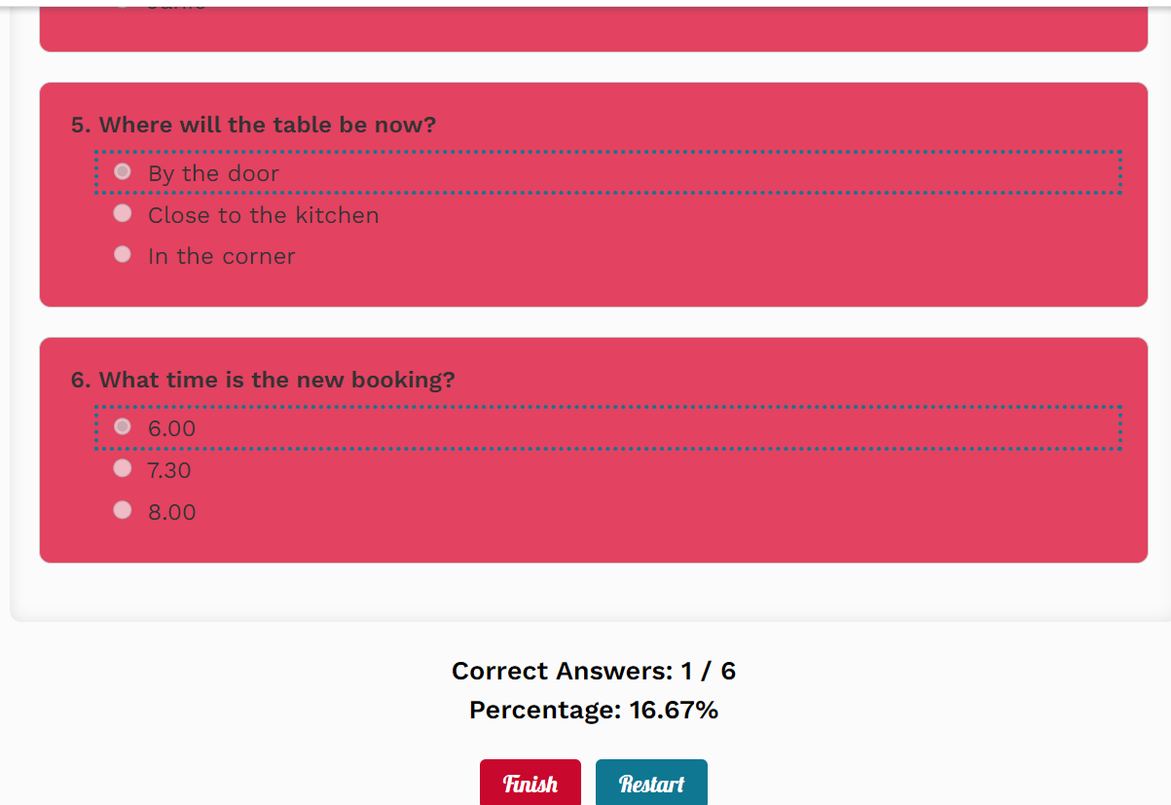

TC_026- User Profile_4, Quiz_6c

Check if the website adds the user test grade on the Grades section in profile:

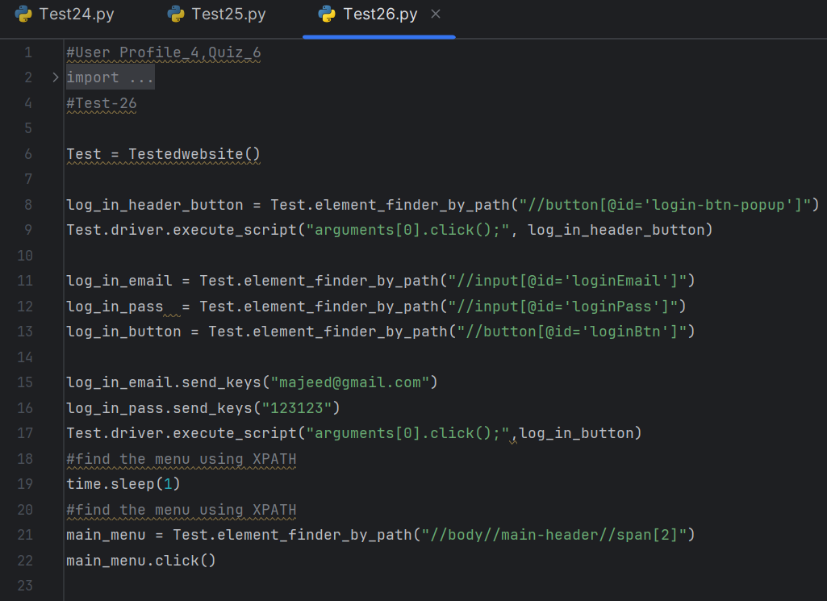

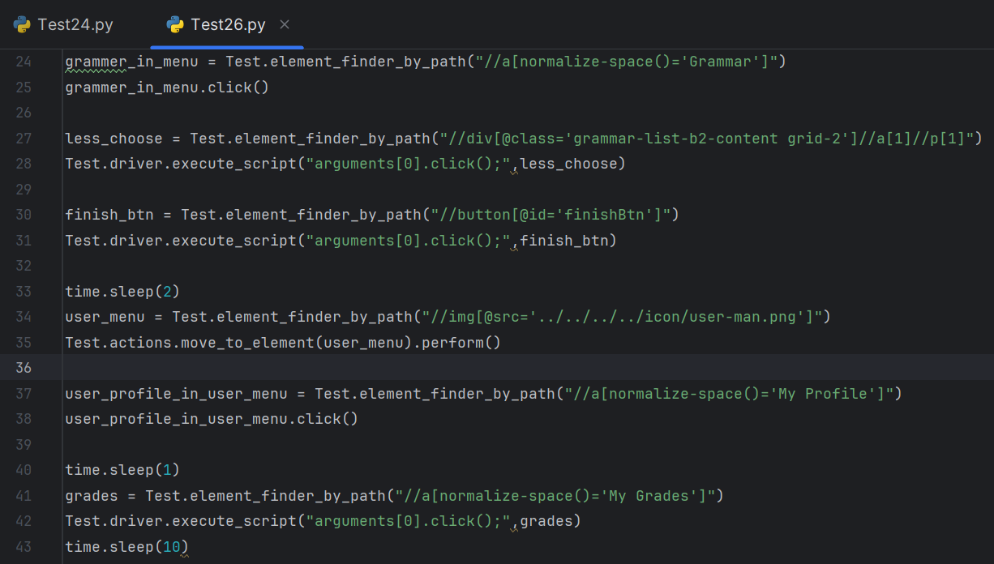

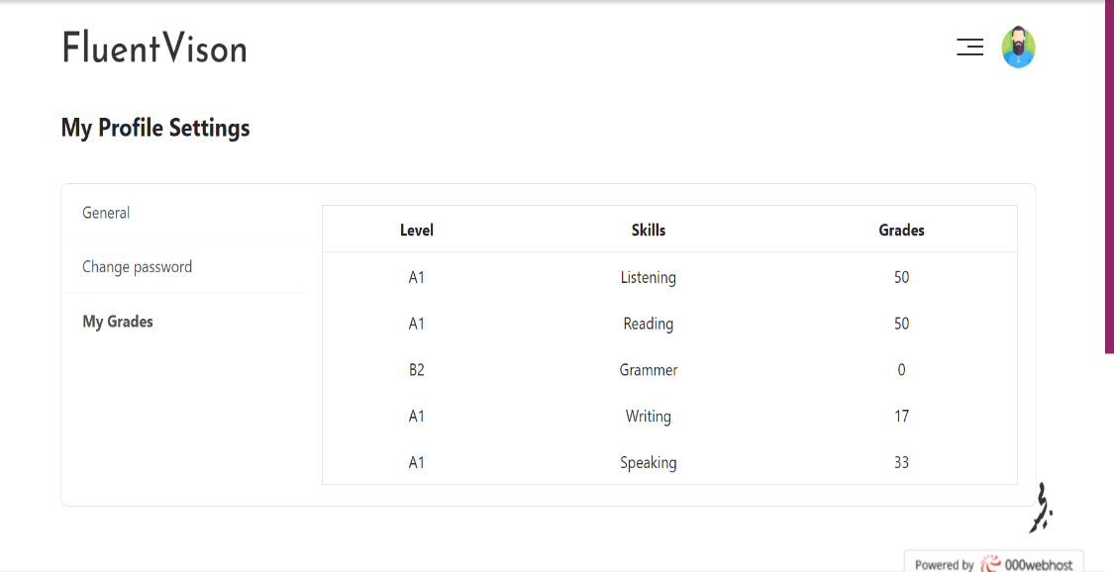

TC_027- Vocabulary_Game

Check if the Play now button in home page or Vocabulary page is working:

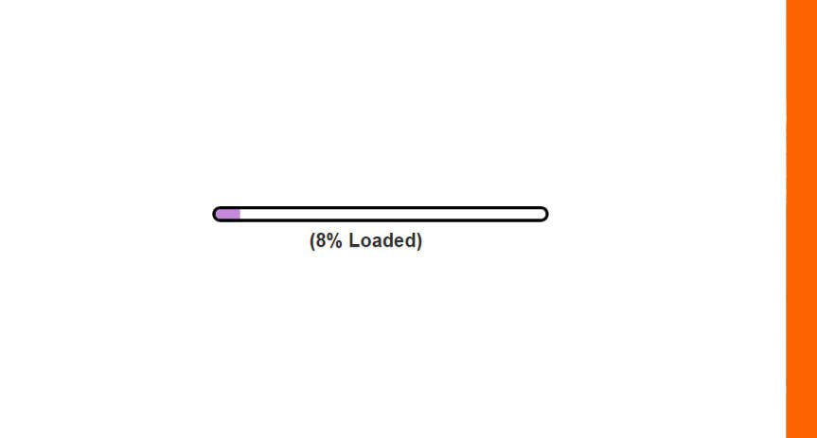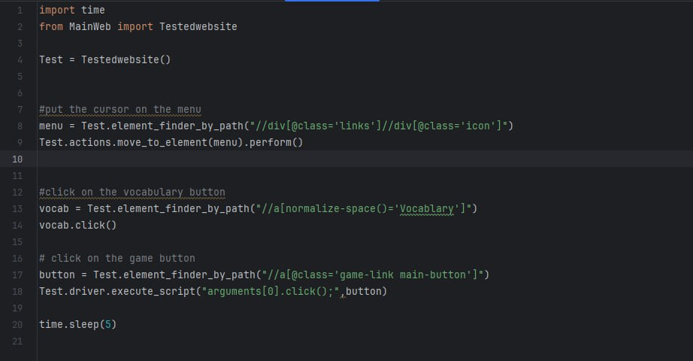

TC_028- Contact

Check if the user can contact us through the email provided:

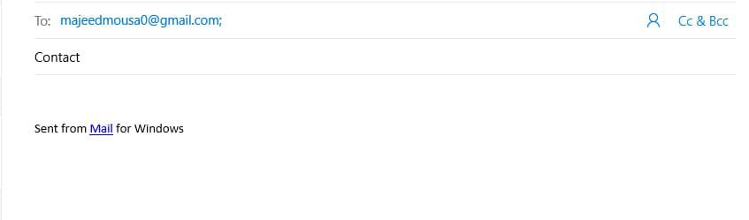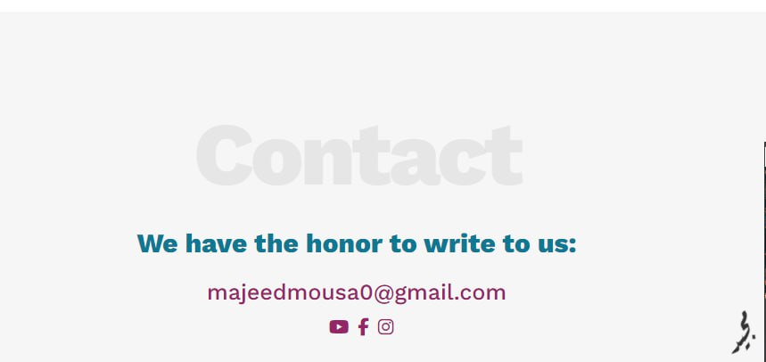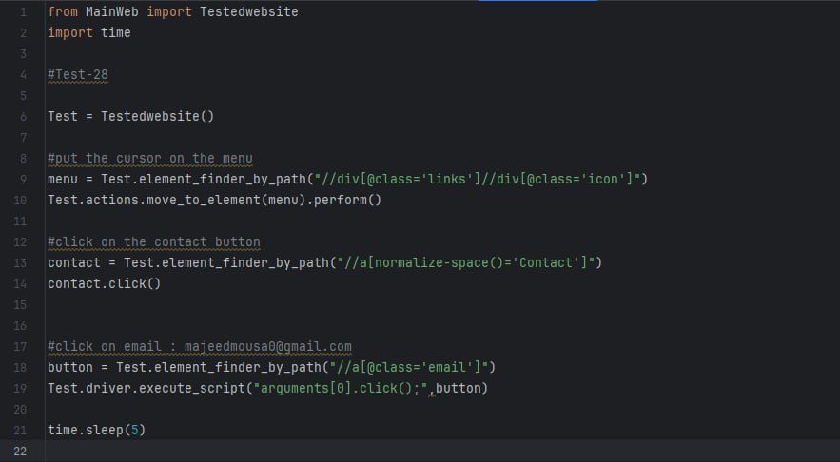

TC_029- Vocabulary button

Check if the website will direct the user to the Vocabulary page:

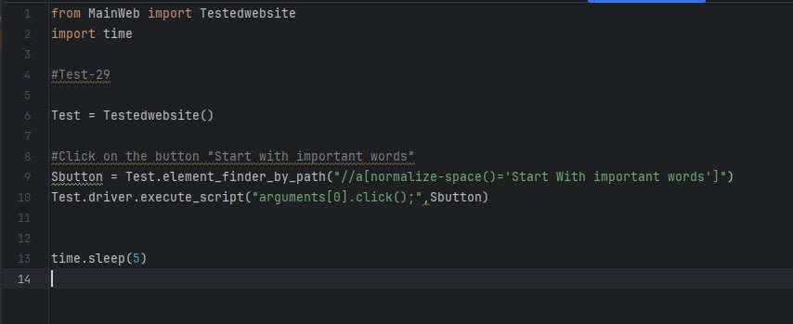

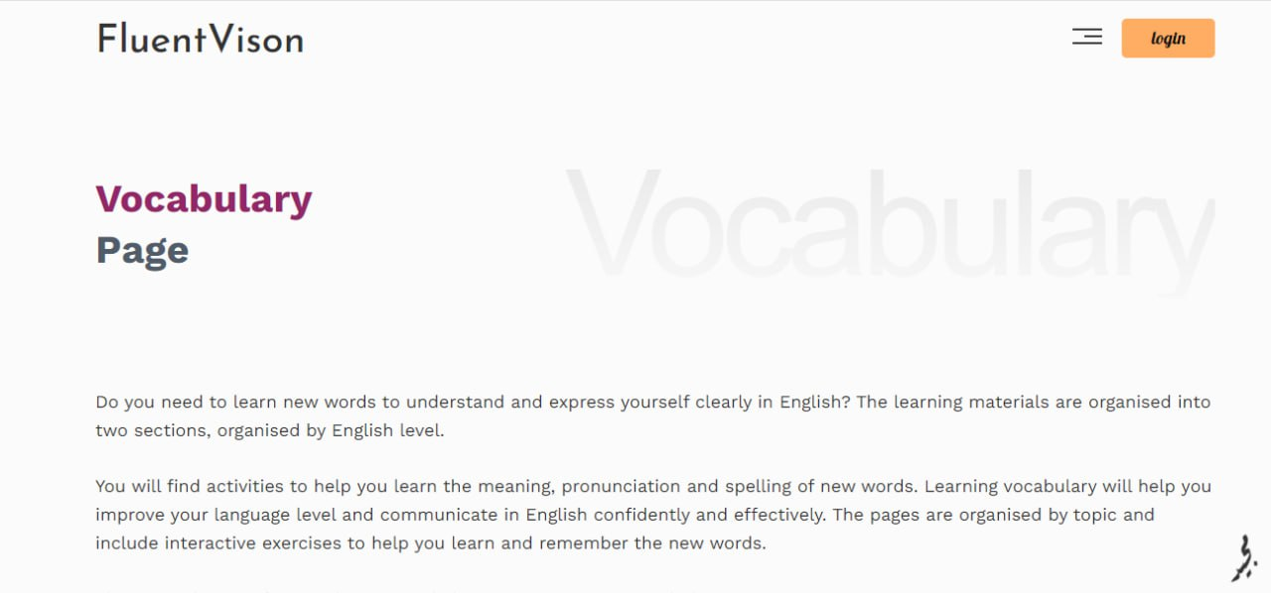

TC_030- logo

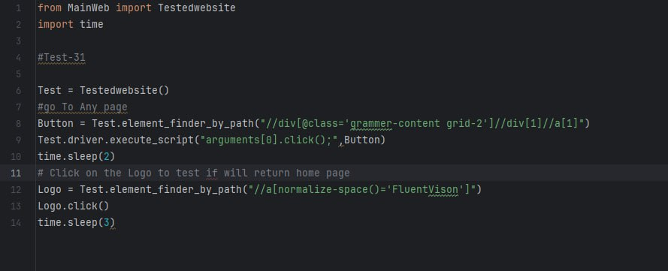Check if the user pressed the logo button will be returned to the home page:

TC_031- Read more

Check if the website will direct the user to the Correct page when he press read more (this test case is applied for all read more button in home page):

